A World Without Ice
A Multimedia Installation

Michael Gould, Sculptor/Musician; Stephen Rush, Composer/Musician;
Marion Tränkle, Scenographer; Henry Pollack, Climate Scientist

Musicians, composers and artists Michael Gould, Stephen Rush and Marion Tränkle have collaborated with climate scientist Henry Pollack to create a multimedia installation that captures a precarious moment in the history of our planet as it experiences anthropogenic climate change. Part science, part music, part art, this collaboration is a groundbreaking, thought-provoking and compelling multisensory experience.

The collaboration takes its inspiration from Henry Pollack’s book A World Without Ice. An original composition by Stephen Rush, with musical patterns and structure derived from a century of climate data, anchors the installation. An innovative ice-melt actuated instrument created by Michael Gould, comprising suspended ice domes melting drip-by-drip onto an array of differently tuned drums, complements Rush’s score. A film by Marion Tränkle blends beautiful photographs from both the Arctic and Antarctic by Pollack and his colleagues, to provide a slowly evolving large-scale visual envelope for the installation. The musical composition carries the listener through large leaps in temperature, the randomly dripping ice yields an eerily beautiful and natural companion sound, and the film provides a stunning visual immersion. The overall narrative of the imagery takes the viewer from a totality of ice, slowly evolving into landscapes of ice, land and water, eventually to reach an enveloping ocean that characterizes Earth without ice.

The exhibit creates a unique space in which visitors can contemplate Earth’s changing climate, and shape their own perspectives of this ongoing global transformation. No visitor leaves the installation unchanged.

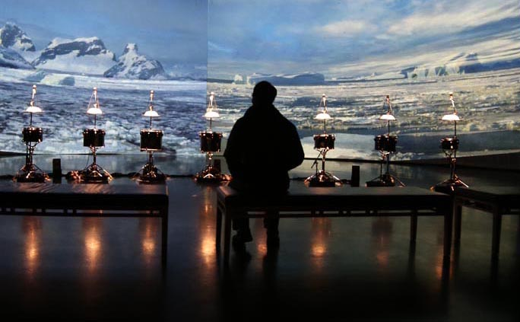

Henry Pollack is a Professor of Geophysics (emeritus) at the University of Michigan. He has served on many advisory panels for the National Science Foundation and the National Research Council, testified before National Academy of Science and U.S. Senate committees, and provided briefings about climate change to Congress and the White House. He has published widely in scientific journals, is a science advisor to former Vice-President Al Gore’s Climate Reality Project, and was a Contributing Author to the Nobel Prize-winning Intergovernmental Panel on Climate Change (IPCC) Fourth Assessment Report. Pollack authored Uncertain Science…Uncertain World (Cambridge University Press, 2003), a book aimed at a non-scientific audience, in which he discusses scientific uncertainty and the role it plays in the formulation of public policy. In a second book A World Without Ice (Penguin, 2009), he guides readers through the topic of global climate change, as seen through the prism of ice.

Marion Tränkle works in the field of performance art, integrating electronics into stage scenographies. Her environments and visual scenarios deliberately negotiate the creative tension between the carefully constructed and generative processes, between risk and responsibility, and between autonomous performance and human intervention. Tränkle’s artistic work has appeared in the Thessaloniki Biennale, Bavarian State Opera Munich, Artefactfestival for Art and Media Leuven, Minimal Music Festival Amsterdam, and the University of Michigan USA. She received an Engineer Diploma in architecture from the TU Berlin, holds degrees in Contemporary Dance from the Amsterdam School of the Arts and from the Media Technology program at Leiden University, and a PhD from the School of Arts, Brunel University London. She has worked for nearly a decade as lighting consultant for the multinational engineering firm ARUP, and has taught at universities and art institutions in Canada, in her country of residence, the Netherlands, and in her native Germany.

Stephen Rush is a Professor of Music at the University of Michigan. He has written many operas, concertos, and symphonies, had performances by the Detroit Symphony and the Warsaw National Symphony, and written hundreds of works for dance, chamber and electronic media. His first book was on Jazz theology and called Better Get It In Your Soul, and has a new book called Harmonlodics with Ornette Coleman: Free Jazz Revelations (Routledge Press, 2016). He founded the Digital Music Ensemble, premiering works by John Cage, Philip Glass and La Monte Young. He also tours and records with his electronic ambient band, “Crystal Mooncone” with Chris Peck and Jon Moniaci. He has released more than 35 CDs of his classical and jazz compositions, and has performed with Roscoe Mitchell, Henry Grimes, Eliiott Sharp, as well as his jazz trio “Naked Dance” with Jeremy Edwards and Andrew Bishop. He is deeply invested in ‘installation art’, working with scientists and artists to explore issues and topics such as Climate Change and Dark Energy.

Michael Gould is a Professor of Music at the University of Michigan, in the Jazz and Contemporary Improvisation Department in the School of Music, Theater & Dance and in the University’s Residential College. Gould has received international recognition as a performer and scholar in the field of drumset, contemporary percussion performance and pedagogy. He has performed and presented clinics worldwide, and released over 100 educational percussion videos through playalongmusic.com. He has also composed and performed music for a wide range of ensembles and venues, from the Münich Opera and Ballet to National Public Radio. He has had unique collaborations with engineers, material scientists, painters, poets, dancers, athletes and business professionals. His 2012 book The Drum Diaries for the iPad is available worldwide through the Apple iTunes store. Gould is also the music director for Tangente Dance Company in Berlin, and a member of the Board of Advisors for the Percussive Arts Society. His recent piece Remember Me was performed at the Kunsthaus Dahlem in Berlin, and includes dance, theater, percussion, electronics, and original artwork.

****

Acknowledgments: We thank Charley Wheatley, Rich Pagen, Jordan Spielman, and EYOS Expeditions for imagery; Jeffrey Alder, Guy Meadows, Tim McKay, Patterson McKinney, Jacques Mersereau, Alvin Hill and Stephen Ragsdale for conceptual and technical guidance; the Perry V. Haines Foundation, the Evolve Foundation, and Oliver Ames for financial support; Kerrytown Concert House, the University of Michigan School of Music, Theatre & Dance, the U-M College of Literature Science and the Arts Residential College, and the U-M College of Engineering Duderstadt Center for institutional support and performance space.

