Strategies for Promoting
Interdisciplinary Arctic Research at UNH
Wed Sep 13th, 2017
Morse 401

Attendance: Steve Frolking, Cat Ashcraft, Liz Burakowski, Jennifer Brewer, Cameron Wake, Ruth Varner, Mike Milankovitch

Guest: Dr. Henry Pollack
Professor of Geophysics, Emeritus
Department of Earth & Environmental Sciences
The University of Michigan

“The New Face of the Arctic” - Seminar at 4:00 pm in Holloway Commons

Agenda
- Welcome and Overview
Goals of Arctic Seminar Series and J-term Workshop
- Round-table Introductions
- Discussion based on Guiding Questions
- Summary of Outcomes and Next Steps

Guiding Questions

- What are UNH’s current strengths in Arctic research and where can we continue to excel?
- What strengths in Arctic research do we want to build over the next 5 years?
- How can interdisciplinary research help make UNH a national/international leader in these areas?
- What should we concentrate on over the next 5 years to strengthen interdisciplinary Arctic research at UNH?
- How will enhancing interdisciplinary Arctic research address the six visions and values of "UNH in 2020"
- A deep commitment to interdisciplinarity
- A broadened definition of scholarship
- An enterprising spirit
- A budget system aligned with strategic priorities
- A culture of inclusion and diversity
- A commitment to sustainability
Introduction – Goals of this Arctic Seminar Series and Workshop

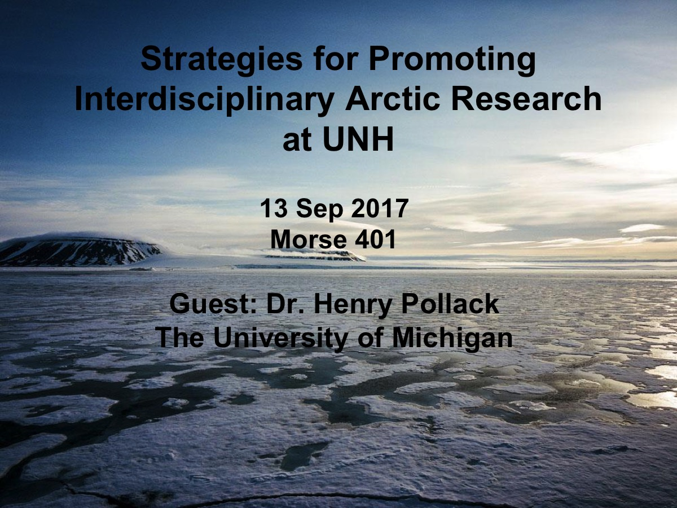 | 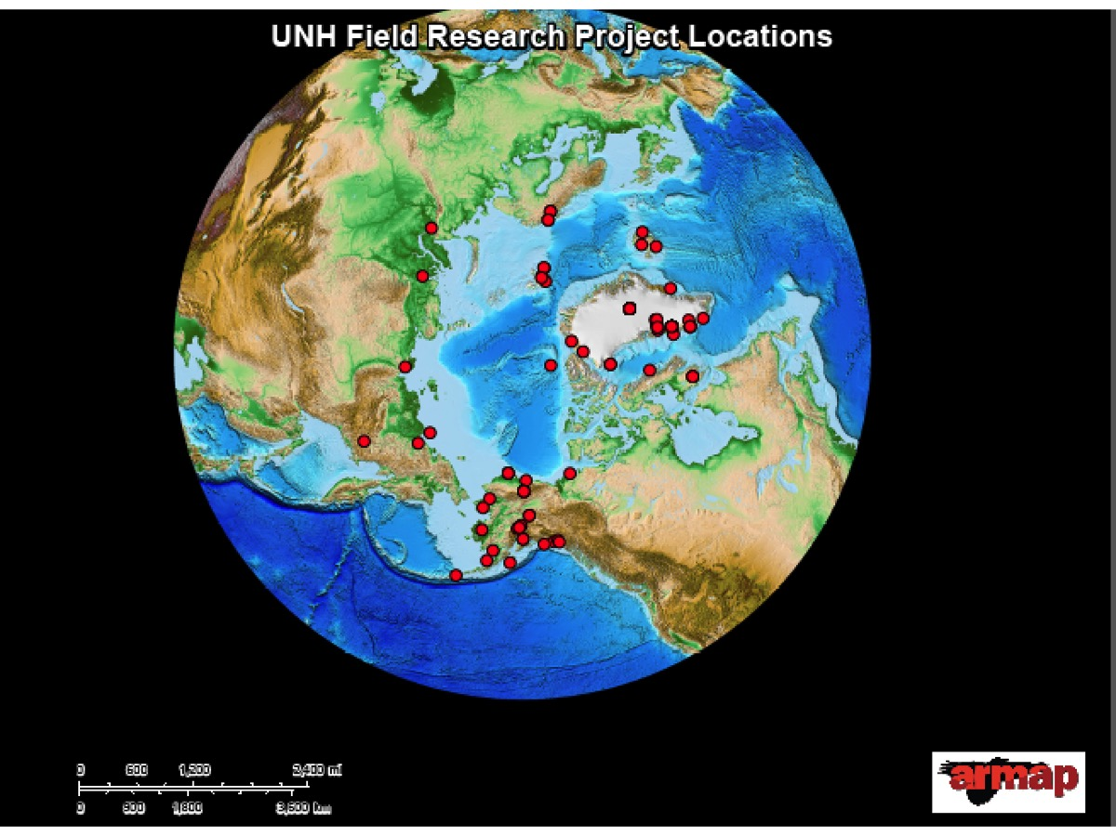
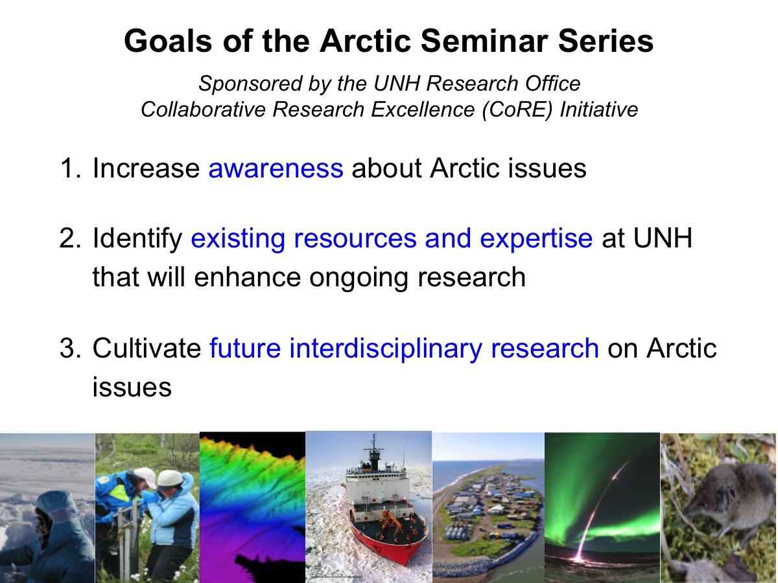 | 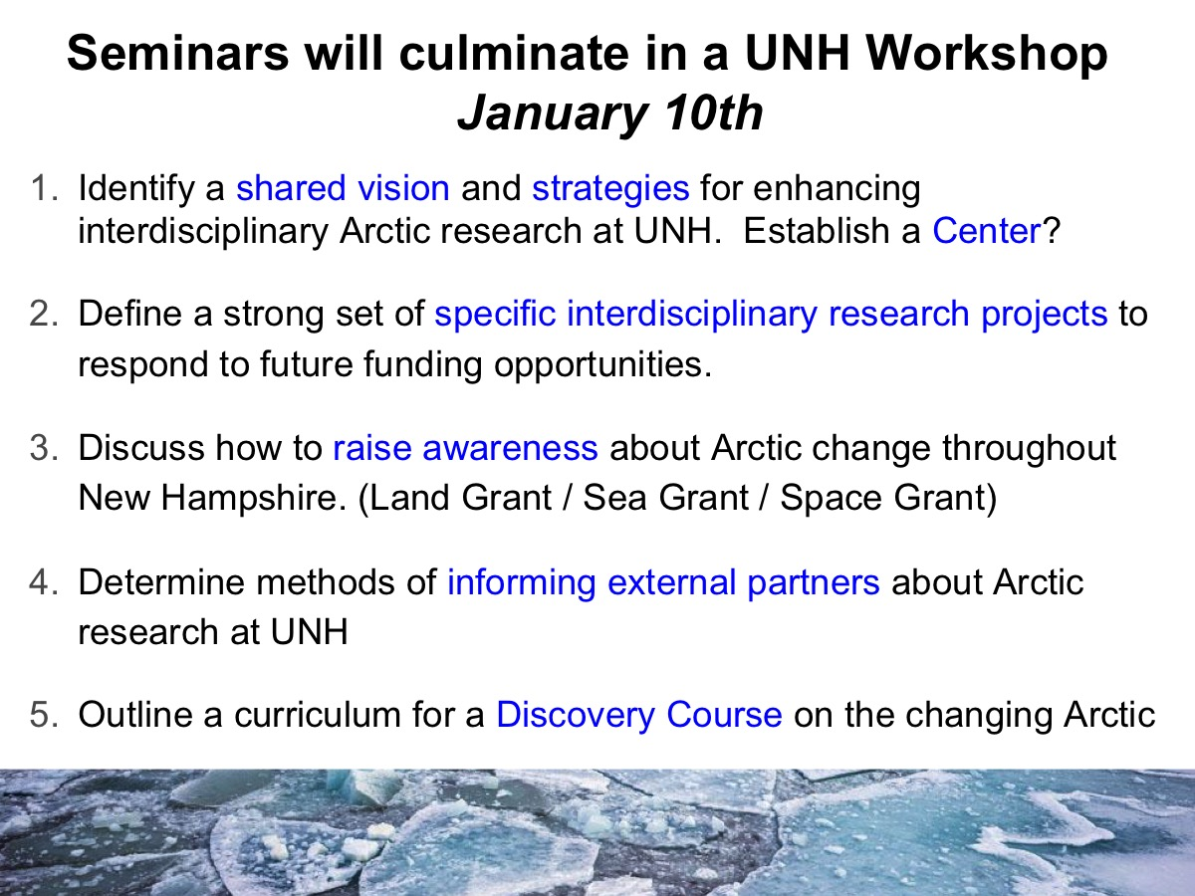
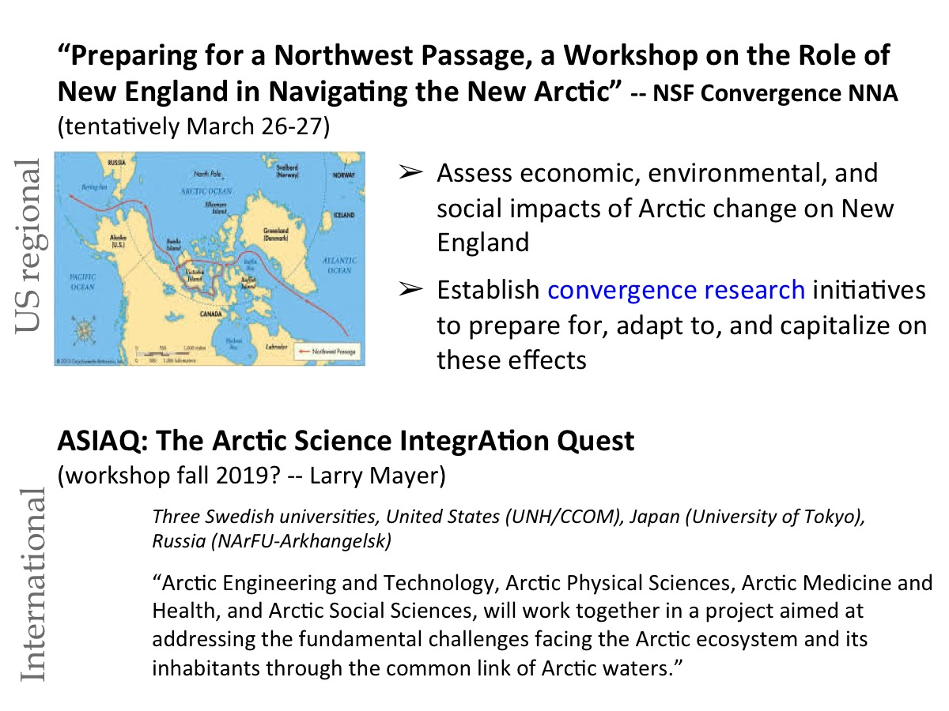 | 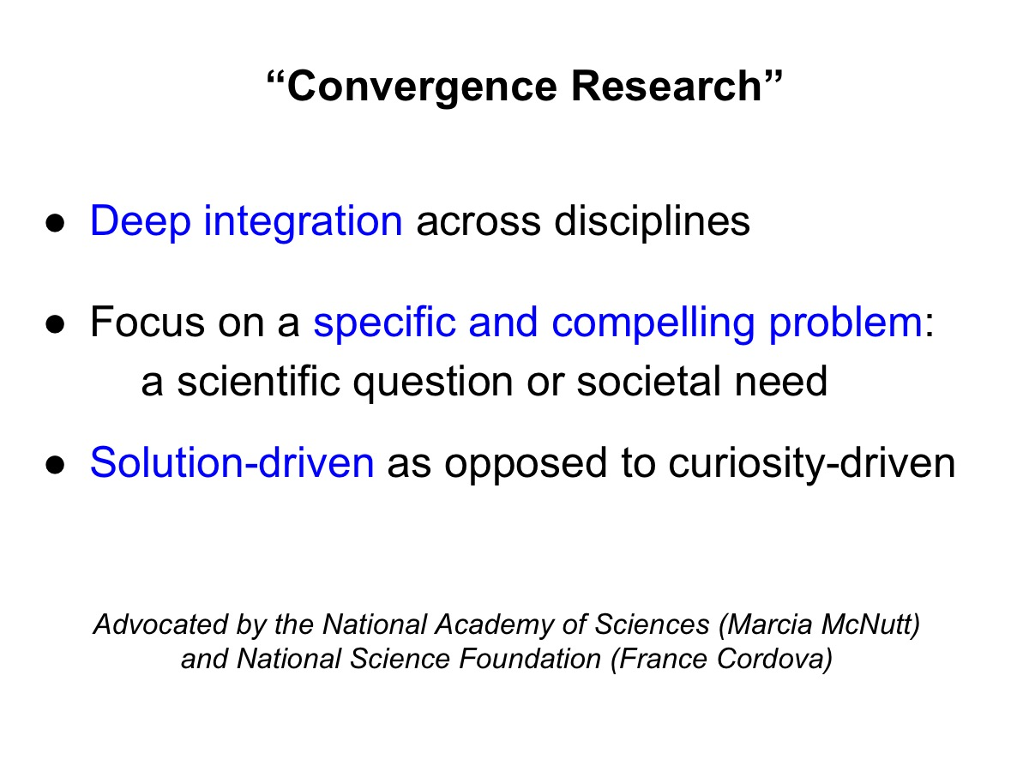

Key Points from the Morning Meeting with Dr. Henry Pollack:

1) Why strengthen interdisciplinary Arctic research?
- Problems resulting from Arctic change can only be solved by diverse sectors and disciplines working together
- "A good institution is more than the sum of its parts"...and is enhanced by interactions.
- Future funding opportunities will address "grand challenges" that require interdisciplinary collaboration (e.g., NSF Navigating the New Arctic)

2) How do we raise awareness of Arctic issues throughout New Hampshire?
- Start local...identifying shared values to capture hearts and minds
- Example: trends in Lake Winnipesaukee freezes and thaws (NH climate data)

3) How "deep" is the UNH strategic value: "A Deep Commitment to Interdisciplinarity"
- Is it also embraced by individual schools and colleges? (Deans need to "buy in" along with upper-level administration)
- Is the university willing to change its "reward system" in order to reward faculty for pursuing interdisciplinary research and engaged scholarship? (especially tenure-track faculty and soft-money researchers)
- How could the university reward quality over quantity?
- Identify specific institutional support systems and obstacles that will need to be addressed to ensure success.

4) Regular face-to-face interaction will help develop a strong network for collaboration (the "social glue").
- It would be ideal to have collaborators housed in the same building
- On a more do-able scale, begin with social gatherings
e.g., weekly drop-in lunches or happy hours
(challenge these days...with more family responsibilities, etc.)

5) Identify specific and compelling Arctic problems to tackle, where UNH could apply its strengths and differentiate itself from other institutions.
- Henry suggested:
1) the Carbon Cycle -- bringing together permafrost, watershed, and coastal marine groups
2) the impacts of freshwater from Greenland and the thawing Arctic watershed on properties of the North Atlantic Ocean, such as thermohaline circulation. Arctic/Atlantic will take up more CO2 – more acidic.
- Cameron suggests the Arctic Water Cycle
- Ask faculty for their ideas

6) Collaborations with other institutions
- Reduce competition by having competitors join our team
- How do we move from individual collaborations to institutional collaborations?

7) Reach out to private foundations who are more likely (than government organizations) to fund interdisciplinary projects, especially those that include the social sciences.
- Start talking with a couple foundations in order to break into the network and understand how to apply for and win grants.
- Work with the Research Office and Advancement Office to identify foundations as well as UNH alumni on boards of foundations. (Most proposals that make it to the boards are excellent, and the final choices are often made on a personal level).

Detailed notes…

Barriers to collaboration
Steve: Science, Tech, Policy – been trying to get people in the same place for 40 years. It’s really hard to collaborate unless there is a building to bring people together
Reward Structure – fewer publications…more collaborations.
Engaged scholarship – how we include external partners and reward outreach.

Example of what works: Sustainability dual major.

Cameron – interesting to have a Geographic Focus to bring people together and set the interdisciplinary stage

Henry Pollack – Local awareness of arctic change
Is there a long-term record of Lake Winnepesaukee freezes and thaws
Get the record together to show local impacts – to see Arctic.
Can’t count on them to be impressed with what is at Arctic - -need to bring this together.
Starting local to capture hearts and minds

Liz - also a way to get at shared values
and economic impact.

Differentiate UNH
– skills is one way…
Social Science and humanities

Focus on specific and compelling problems.
Terrestrial ecosystems – strong watershed modeling group.
Field work
Carbon cycle as a focus?
Another compelling problem – Arctic Ocean.
Thermohaline circulation – and watersheds
Arctic rivers increasing wintertime flow, being fed by groundwater as thawing deepens.
Greenland connection to Arctic Ocean…
Sea Level Rise?
Sea level rise not an Arctic problem…and here is NE is not as bad as elsewhere
Sea level rise is straight forward… and people can connect to local awareness

Partnerships with colleagues at other institutions.
Good at it…but not strategic, institutional level.
How do we go from individual to institutional?
Instead of competition, they are part of the team.
How to deal the other Centers (Darthmouth and Tufts)

Outreach to private foundations. Private foundations have a broader interest than NSF…so much more room to amplify social implications for what we are doing.
Usual sources focus on science….here is an opportunity to expand the social science (Deep commitment)
Foundation – POW REI Liz Burakowski
Mark – Advancement office –looking for foundation and private… people embedded in units around campus.
Research Office and Advancement

Are there off-limits domains?
Support system may look like a barrier – but can smooth contact.
Go through university.

How “deep” is the Deep institutional commitment
Universities very slow to change…
“Bean counting” – no effort in accessing quality of research…only quantity.
Deep commitment – assessing quality and impact. Make reward structure reflect quality.

University needs engagement by faculty – integrating not isolation… faculty feel entitled if they don’t have to engage.
Co-teaching. Commitment of time and effort – times two… Seen as inefficient by deans…but doesn’t take into account the quality of the course.
Recognize that not everyone can be above average – there is always a low end of normal curve…and those people need to be there.
UC Santa Cruz – evaluation experimentations with changing faculty reward structure. Not sure how it worked out.
Henry mentioned success of freshman seminars – small numbers – higher quality education.

Note: this is being addressed by Research and Engagement Academy – at UNH

Find out where UNH graduates sit on boards of major foundations.
Once proposal reaches the board, they are all good.
Know where your alums.

For interdisciplinary collaboration in research and teaching to succeed…
Individual people have to put the time in… and feel appreciated.
If you want to deal with teaching part, have to deal with Dean silos, so
Faculty receive full credit for co-teaching or teaching in different departments

Approach Heidi Bostic and and Wayne Jones

----------------------------
Social glue – needed to keep interaction going.
Faculty weekly luncheon – get together – informal
Informal but frequent contact.
Don’t eat a sandwich at your desk…go out to lunch or happy hour.
(Cat noted family obligations, like picking child up from daycare, make this difficult)
Need to keep in mind how people socializing at work needs to change to accommodate change in demographics in academia).

“A department that is only the sum of its parts is a failed department”

A good department is more than the sum of its parts – coming from interactions.
Comes back to Steve’s idea of being housed in the same building.
Have to have a team mentality.

Educating the administration is part of any breakout initiative
Upper level admin understand it.
Hindered by funding mechanism and bureaucracy.
Value added for students benefit by interdisciplinary research

Next Steps:

1) Get together with Mark to discuss private foundations
2) Pursue ideas of specific Arctic problem to tackle
carbon cycle
ocean thermohaline
3) Plan future meetings with a focus on specific Arctic problem
4) Find out about “deep commitment” – how deep is it?
White paper of what we need – to give to university (J-term workshop?)
5) Weekly lunch – social hour…
6) Start local to win hearts and minds for Arctic awareness

