“Elephant,” “The Zone of Interest,” and Naturalism
The line between reality and creative works of art is so thin it is almost non-existent. As Oscar Wilde reminds us, sometimes “Life [even] imitates art more than art imitates Life.” The purpose of this essay is to discuss this relationship between real events and their factualization as it occurs in the narrative of film. 2 case studies will be used, films based on real historical events within the last century, contrasting them to the historical documents and photographs from the same incidents. The film “The Zone of Interest” (2023), is based on the Höss family, who lived adjacent to the Auschwitz concentration camp. The film “Elephant” (2003) is a fictionalization of the Columbine massacre, an event that had happened less than 5 years before the movie was produced. Although both films could be classified in the Drama/Thriller category, they contrast with other movies of the same genre in their more subdued qualities of image design and narrative construction, demonstrating their dedication to constructing a fictionalized narrative that mirrors the real events most accurately.
“The Zone of Interest,” directed by Jonathan Glazer, is the more recent film, and it is by far the more popular of the two. The production one multiple awards including the academy award for best sound design. I have also seen numerous short video essays online breaking down the different concepts presented in the film. Jonathn Glazer is also widely considered to be the more popular and impressive of the two directors. Before starting out as a commercial filmmaker, he worked as a music video director with high profile bands such as Blur, Radiohead, Massive Attack, and Jamiroquai. In an interview with the filmmaker, Glazer claimed that his work directing for these bands helped him hone his style of filmmaking. In the decade before
“The Zone of Interest,” Glazer directed the film “Under the Skin” starring Scarlett Johansson as an alien 'body snatcher' making her way throughout Scotland. In this movie, Glazer’s unique style of filmmaking that embraces toned down, natural styles of acting and filming enhanced the narrative of an extraterrestrial woman attempting to identify as a human. Entire sequences of the film are shot in public, utilizing hidden cameras and having Johansson interact with strangers as if she were in this situation. The film almost resembles something like a vlog or some sort of performance art.
The candid way of shooting would have been labeled a gimmick had it been directed by any other filmmaker, but Glazer’s dedication to the naturalism of the storyline instead makes the film feel technically and thematically competent. The lighting is unchanged in production from the way it would appear in real life; most of the scenes that take place at night are dark and difficult to make out, and scenes that take place inside show lights as huge bright spots. Even sounds are stylized in this naturalistic way, the car engine drowns out dialogue, thick Scottish accents are difficult to understand. The term 'documentary style' is a fitting way to describe the film, closer to real life than an actual stylized film set.
The same sort of mindset surrounding the production of “Under the Skin” in 2013 was continued in the development of “The Zone of Interest” a decade later. The plot, concerning a family living on the border of a concentration camp, seeks to provide a deeper examination of the perpetrators of the Holocaust. The film aims to demonstrate these people as not a mythological evil, but simply a family doing what they are told to do in an extremely politically tense time in history. Similarly to the slow filmmaking style of “Under the Skin,” not all scenes in “The Zone of Interest” are meant to drive the plot. Many feature the family simply living their life like any other.
The film is based on the real lives of Höss family, Germans living outside of Auschwitz whose patriarch (Rudolf Höss) was the Nazi commandant of the concentration camp. Real video and photographs and firsthand accounts from Höss’s autobiography were used to reconstruct this specific moment in time. When comparing the film to these real artifacts, the accuracy of the depiction of the family and their lifestyles is clear. Four core concepts for discussion emerge in this comparison between the real historical events and the fictionalized versions created in the film.
The first idea connecting the film to the historical events it is based off is leisure. In the movie, the family is shown in sparse moments relaxing, swimming, camping, and playing. Although these scenes are generally undercut by the father’s preoccupations or interrupted by events occurring in the Concentration Camp next door, they still connect themselves directly to the photos from the real Höss family.
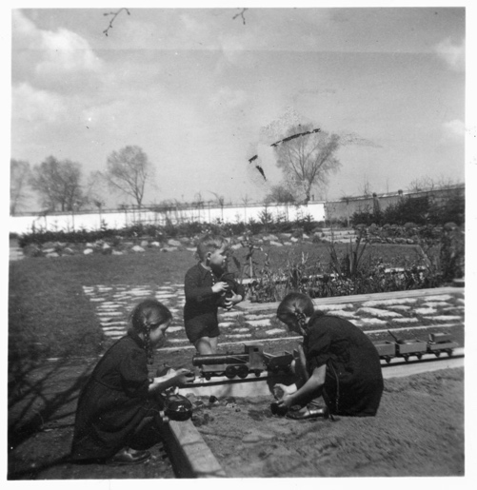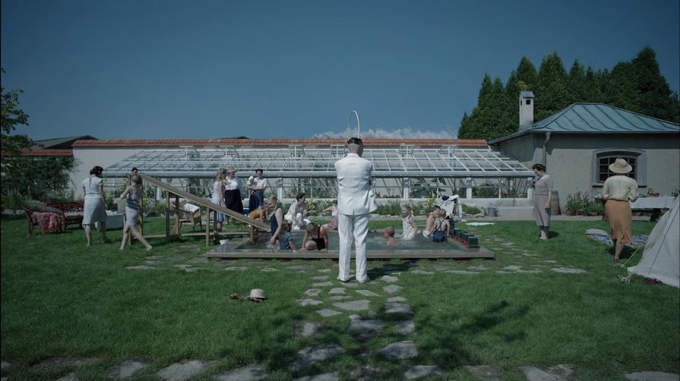
In both the real photo of the Höss family (top left) and the film rendition (top right), the children occupy and play in the of the garden. The sky is particularly dark, almost blending in with the trees and buildings laying on the horizon. This creates an unsure and sullen about what lies outside the bounds of their home. It also reminds the audience and viewer of the photo that, even if surrounded by family and loved ones in a joyful environment, war is still inescapable and present outside their garden walls.
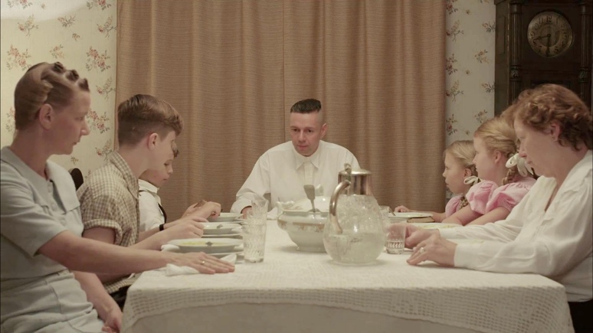
The second concept shared by both the historical documents and the film is the family themselves. The family is often depicted in arrangements that place them as if they are being staged for a family photo (as seen above in a snapshot of a dinner table scene). A lot of the film is concerned with the structure of the family, and how it's threatened by the order of operations involved with living next to a concentration camp. Rudolf Höss, the father, is shown to be a particularly stern man, with an almost cowardly air about him. He seems concerned about his children, keeping them sheltered against the atrocities being commit outside of the house. This idea is particularly morbid contrasted against the carelessness involved with killing people in masse.
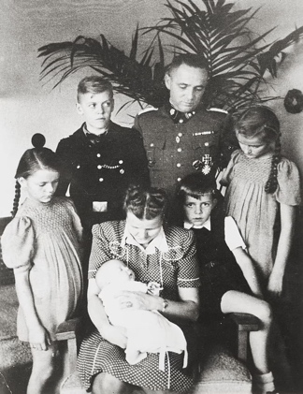
In the real family portrait (above) of the family, Rudolf is surrounded by his family and is looking down at his wife and children. There seems to be concern present in his expression, we can assume for his children, spouse, job and position. The mother, similarly, is largely concerned with the youngest child, a character trait she is represented with in the film.
The third concept, and the last one directly involved with the family itself, is work. The only member of the family involved in the work of Auschwitz is Rudolf Höss. This becomes his main character trait in the film, presented as a particularly stressed, and sometimes sad man, someone who is caught up in this situation.

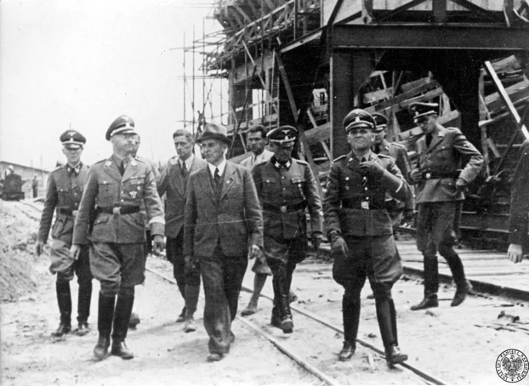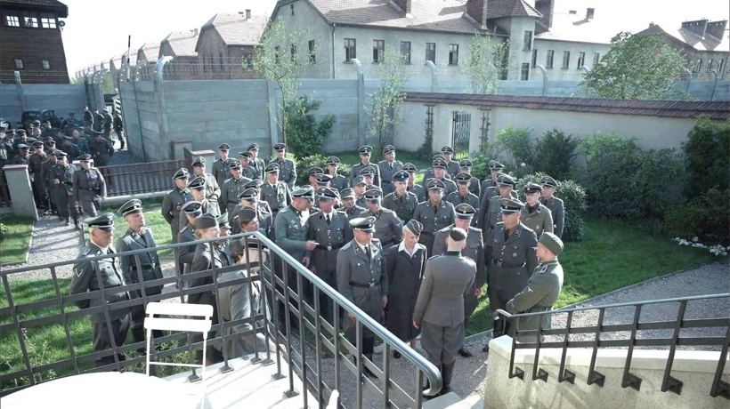
While the real photo (above left) is not particularly interesting, it is important to connect Rudolf Höss to the rest of the SS just as he is in the film (above right). It also reminds viewers he was still complicit in the crimes committed against the millions of Jewish people that were murdered in Auschwitz and the Holocaust. Eventually, his work life winds up tearing the family apart, forcing them to hide away in an abandoned factory until they are discovered in the search for Höss.
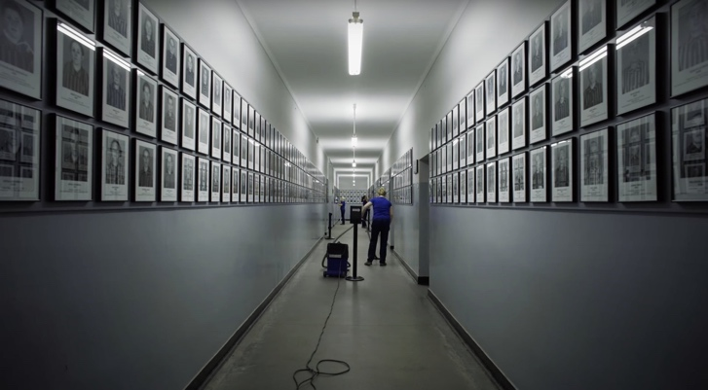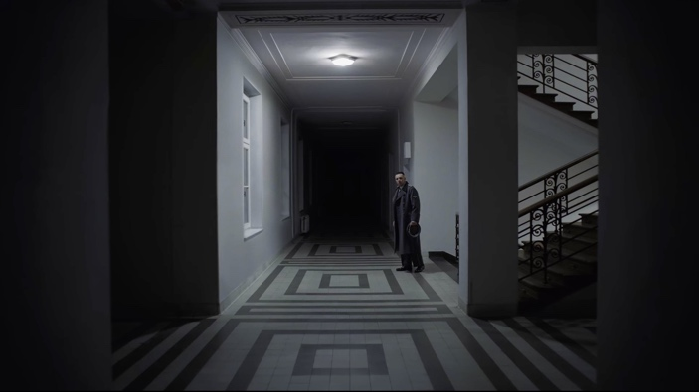
The fourth and final concept that the fictionalized narrative of the film and photos and documents from the Höss family share is the concept of aftermath. What is happening outside of the walls of the home is largely kept secret throughout the film. Aside from distant gunshots and screams, the only real interaction the audience gets to have with the tragedy taking place is in the end of the film. After leaving his office to return home, Rudolf Höss descends into the building to reach the ground level. The corridors grow darker and darker, and Hoss retches at something unknown to the viewers, eventually coming to rest staring off at something down a long, dark corridor (the image top right). Then, for a few moments, the film cuts forward to the modern Auschwitz Museum, showing current museum cleaners. The similarities between the movie shots (one more fictionalized than the other) makes it feel as though Höss is looking at the cleaners of the future museum, offering to the audience a moment of possible reflection on Höss’s part as well as a reminder of the long-term implications of his horrific actions. In the end, it implies that Höss intentionally chose to continue working with the SS and Nazi régime, actions leading to the construction of the museum he is “looking at.”
The Film Elephant (2003) directed by Gus Van Sant, is another work that presents a fictionalized narrative of real events to its audience. Originally intended to be a documentary about the Columbine Massacre of 1999, the project eventually evolved into a separate narrative perspective. Rather than focus on the perpetrators, the film covers a series of events that occur immediately before a school shooting. These series of events are intentionally confusing and nonlinear, intending to reflect the emotional shock and disorientation experienced by the people involved in the massacre.
The visual and narrative style of the Van Sant’s pulls inspiration from a 1989 film directed by Alan Clarke with the same name. Clarke’s “Elephant” is also routed in true events, focusing on the Troubles in Ireland, specifically a string of murders that lasted decades of the politically volatile time. The structure of the original film is extremely similar to Van Sant's “Elephant,” showing a series of incidents involving normal people and their interactions until each scene ends in a shooting of some kind.
The fundamental idea behind Clarke’s “Elephant” is that violence is meaningless, depicted as an action that is drained of all energy, as a chore to be carried out as opposed to an action with definite meaning. The slow, quiet style of filmmaking in Clarke's “Elephant” is reflected in Van Sant's film. The two productions use color in a similar way (as seen in the comparisons of images below, 1989 “Elephant” below left and 2003 “Elephant” below right), stylizing images in a striking manner. This push of color towards blue, green, or yellow creates an atmosphere reminiscent of newsreel or documentary footage, footage that may have improper lighting or color grading.
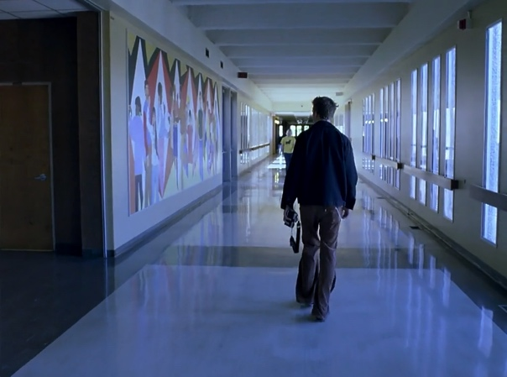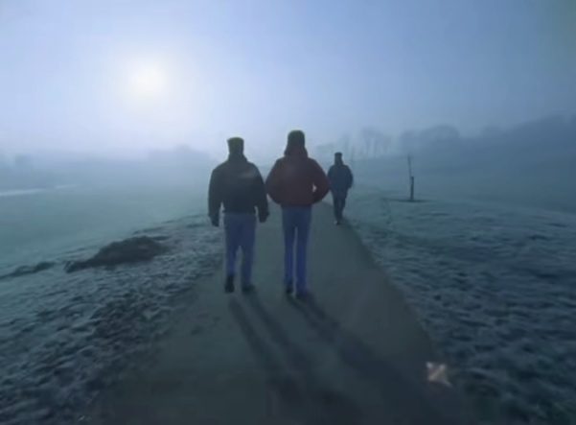

Harris Savides, the cinematographer responsible for the quality of images presented in Van Sant's “Elephant,” is a particularly interesting individual. His style is particularly focused on naturalism, creating images that look and feel like older films. While working with Van Sant starting in the early 2000's, Savides was allowed to take charge of the process of creating images. The cinematography of Van Sant’s “Elephant” particularly reflects this mentality, shots are frequently out of focus or shaky, particularly on the back end of the film. This distinct style of photography that Savides adds to the film heightens the intentionally un-cinematic quality of the final production. From a historical standpoint, this newsreel style of film makes sense. Columbine, when it happened, was shown on the news on a national level. The tragedy was one of the first nationally covered school shootings in America, with echoes of its coverage still being seen today. This “Elephant” focuses the subject of the film, on violence without explicit messages about gun control or the motives behind the shooters.
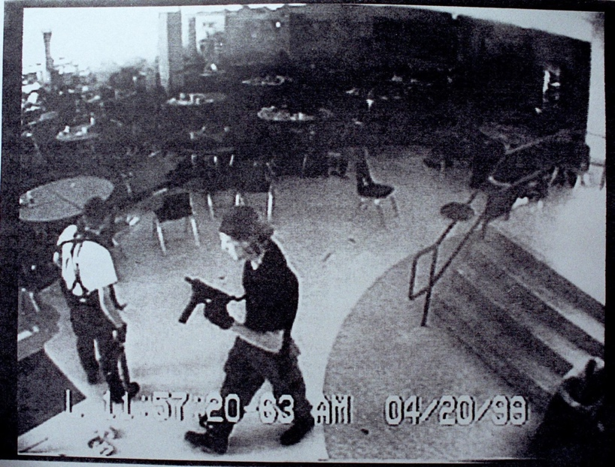
The first, and most notable photograph that I found as a real historical document that related to the film’s fictionalized narrative style is a picture of the Columbine shooters. The image was not taken intentionally, instead captured from the security cameras. The picture was not taken with any sort of intention, it wasn't even taken by a human being. Instead, it was given as a form of context after the event, showing the two shooters passing through the cafeteria in dim lighting. The background is blown out to the point where it becomes solid white in the top right corner of the picture. Other areas of the photo are significantly darker, as this photo was not taken with any sort of set lighting or adjustments. Van Sant's “Elephant” uses the same image quality in the film production. The lighting of the cafeteria of the set is unusually dark, with the daylight from the windows overexposing the rest of the scene. The photo-visual decisions in “Elephant” are not concerned with drama or emotion, instead only capturing scenes as they are and would have been.
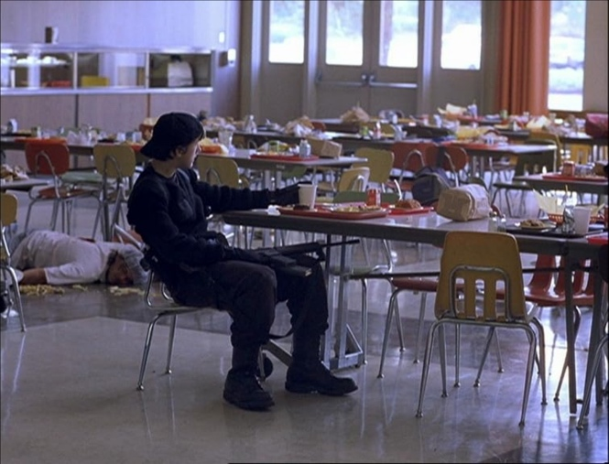
There are still clear differences between the staged shots from “Elephant” (above) and the candid photo from the Columbine high school. The shooter in “Elephant” doesn’t appear concerned with making his way around the school but seems bored and even takes a moment to sit in the cafeteria as a witness to his own horrifying actions. In the context of the film, this moment isn't given any greater purpose besides showing the shooters as illogical people. Although the real perpetrators of Columbine did not take this pause, these changes aren't drastically different from the original photos, they bear a clear resemblance to the tragedy despite the addition of a fictionalized plot.
The students are a particularly important focus of the film, most of the footage shown revolving around their actions before the moment of tragedy. A student is shown making her way to the library, another student prepares to leave with his girlfriend, and another attends a gay-straight alliance. One of the most important figures in the film is a photography student, who is shown at multiple points taking and developing photos. Even as the shooters make their way into the school, this student is shown taking a photo right before the first shot rings out. The addition of a photographer as one of the characters brings a clearer focus to the mentality of both the film and the real event. There's a kind of voyeuristic element to this tragedy, news stations squabble for as much footage as possible of this event, and rush to show as much as possible on television. Both the fictional and real photos have an uncomfortable element to them, something that says, "you shouldn't be seeing this." The perspective of the film, following the various characters in their daily actions, adds to this messaging and causes the viewer to be complicit in both the real event and the film.
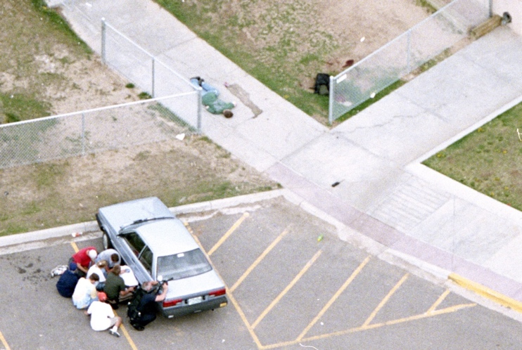
Another historical photograph that mirrors the fictionalized narrative of the film shows multiple students hiding down behind a car, while another student lies facedown and unmoving in the distance (this individual, although unidentifiable in the photograph, is Daniel Rohrbough, a 15-year-old killed by Eric Harris in the Columbine Massacre) (above). A cop peers from behind the car, armed and pointing his gun in the direction of the school where the shooting is actively occurring. The angle of perspective is taken from a helicopter above the scene at a distance and therefore slightly disconnected from the subjects in the photo.
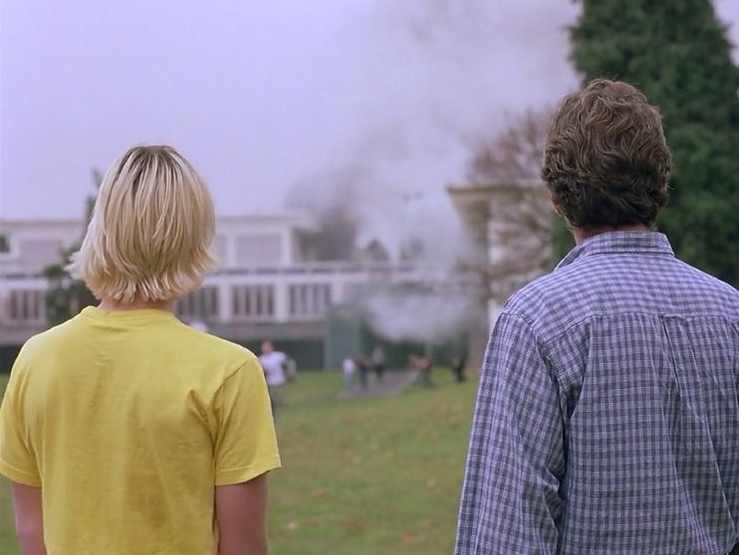
Comparing this historical photograph from a snapshot taken from the film (above), the audience is similarly connected yet removed from the tragedy, with the burning school framed by a father and son watching the events unfold. While the real photo is clearer, the frame captured for the film seems more dynamic, one of the few in the film that seems more focused on capturing emotion.
In analyzing both films, a clear connection between the films and their respective historical events are brought forth. Both films connect themselves to real events in a particularly fragile way, navigating these difficult subjects with clear, well thought out technical decisions. While they are still both fictional narratives staged and put to film, they still surround themselves with the subject of tragedy in a direct manner, covering tragedy directly through interpretations of historical footage and personal accounts. Utilizing a documentary style gaze, these films are more concerned with showing you these events as opposed to telling you what to think.

WORKS CITED
Berger, John. “Understanding a Photograph.” The Look of Things. New York: Viking, 1974.
Dargis, Manhola. The Zone of Interest Review: The Holocaust, Reduced to Background Noise.
The New York Times, December 14, 2023.
Elephant. Directed by Gus Van Sant, HBO films, 2003.
Guzman, Nicole. A Brief History of Columbine and Its Effects. UC Denver.
Harding, Thomas. ““Mum Knew What Was Going On”: Brigitte Höss on Living at Auschwitz, in
the Zone of Interest Family.” The Observer, 24 Mar. 2024,
O'Brien, Geoffrey. Gus Van Sant's Elephant. Artforum, October 2003,
O'Falt, Chris. ‘The Best of the Best’: Honoring the Magic, Guts, and Generational Talent of
Cinematographer Harris Savides. Indiewire, August 15, 2024.
O'Hagan, Sean. Jonathan Glazer On His Holocaust film The Zone of Interest: 'This Is Not About
The Past, It's About Now'. The Guardian, December 10, 2023.
The Zone of Interest. Directed by Jonathan Glazer, A24, 2023.

