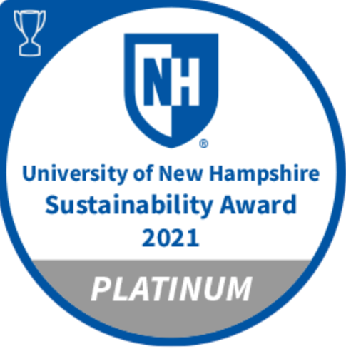

Civil Discourse Lab

Yearly Report 2020-21

civil discourse, freedom of speech, and academic freedom
Awards and Honors
SPRING 2021 The Lab received the UNH Sustainability Institute Platinum Award for Curriculum Development and Teaching in the Civil Discourse Lab.

SPRING 2021 Co-Director Jennifer Borda was awarded the College of Liberal Arts Teaching Excellence Award.

SPRING 2021 Co-director Renee Heath was tapped to give the Convocation Speech as part of a panel on A Conversation about Free Speech, Truth and Civility, “Higher Education in a Democracy and the Praxis of Civil Discourse.”

FALL 2020 President Dean is selected to present CDL work in competitive Lightening Round at APLU Conference.

FALL 2020 Post Doctoral Research and Teaching Associate, Lydia Reinig, is honored with National Communication Association Language and Social Interaction Dissertation Award for "Participating in Boulder's Energy Future: Discursive Configurations of Public Participation for Energy System Transformation.”

The Civil Discourse Lab is proud to have been awarded the platinum level UNH Sustainability Award in 2021. Since launching the Lab in the spring of 2018, we have had more than 1,400 attendees participate in our facilitation events including students, faculty, and the greater New Hampshire community. An additional 429 people have attended our guest lectures and workshops. We have built strong curricular and extra-curricular programs in just three and half academic years. We are excited to share in this year’s report empirical outcomes linked to our work and reported by our former students (p. 5).

Much has happened in these three and half years. Last year, as we sat down to pen our reflection of the Lab’s work, our nation was in the midst of protests following the murder of George Floyd. We had been approached by CDL alumni, Nelson Thomas and Kolby Tracey, asking what they could do. They wanted to bring their experience in the CDL forward to address racism. Indeed, Thomas and Tracey directed their efforts toward stakeholders at the University to advocate for a diversity, equity, and inclusion course that would be required for UNH students. They sought a complementary dialogic space to digest and discuss what they would learn. Something that looked much like our Lab.

This year, perhaps as part of an expected backlash, the New Hampshire State legislature recently passed a controversial budget with language that has NAACP, ACLU, state superintendents, and state legislators concerned. Our university holds firm its commitment that academic freedom remains intact at the higher education level, however, external momentum may lie elsewhere. Many believe the new law effectively works as a “gag order” to chill discussion of race in the classroom leaving teachers legally responsible should their lessons make students feel uncomfortable or ashamed. Critics of the law believe this is an unnecessary reaction to the much politicized “critical race theory.” This theory draws our attention to the ways racism is embedded in structures and systems, particularly the legal system. Indeed, examining systemic and structural racism has been key to almost every public dialogue we have run on and off campus. It is key to thinking through 21st century stakeholder problems.
Mission
To strengthen the ability for our students and community members to conduct meaningful conversations, collaborate, and weigh decisions around difficult but important topics to a civil society through research, engaged teaching and praxis.
By the Numbers 2020-21
154 Cumulative hours of volunteer facilitating, training, and attending related events/lectures

7 Specific Training Opportunities resulted in 32.5 hours students spent in extracurricular trainings this year

Students attended 6 events resulting in
41.5 hours students attended events related in Civil Discourse

14 Facilitation Opportunities resulted in
80.5 hours students spent volunteering + facilitating this year

26 Active* students in the fall
13 Active Students in the spring

Since December 2017

1,354.5 Cumulative hours students participated in facilitating, training, and related events/lectures

502 Hours students spent in extracurricular trainings

449.5 Hours students spent volunteering facilitation

398.5 Hours students spent attending related events (not training)

136 Active students (Extra Curricular, not including course enrollments)

~500 Students enrolled in CDL designed classes: Collaborative Leadership, Public Dialogue & Deliberation, Communication Across Differences, Intro to Civil Discourse, Understanding Civil Discourse (some students will have taken more than one course)

~1,419 Estimated number of participants (faculty, students, and community members) in facilitation events we organized at the University and in the community (some overlap)

~429 Number of faculty, students, and community members who have attended our outside lectures and workshops

*Active refers to students who attended at least one event in the semester and logged their hours with the CDL

As scholars of communication, we hold dear the assumption that meaning is always determined socially, in concert with others. This assumption is at the heart of our work in the Lab. It is in the negotiation of meaning around controversial subjects, married with nonpartisan, accurate information, that gives people the best potential to reach understanding, tolerance, and agreement. We know that we cannot often control how a person, feels, reacts, or interprets meaning. Therefore, we join the growing list of those concerned that the new legislation feeds the present trend to shut down conversation rather than open its potential for change.

Central to being able to conduct this work, and to foster constructive conversations around controversial subjects, is a commitment to freedom of speech and academic freedom. The AAUP described the importance of the tenure system to maintain academic freedom.

“The principal purpose of tenure is to safeguard academic freedom, which is necessary for all who teach and conduct research in higher education. When faculty members can lose their positions because of their speech, publications, or research findings, they cannot properly fulfill their core responsibilities to advance and transmit knowledge. Tenure provides the conditions for faculty to pursue research and innovation and draw evidence-based conclusions free from corporate or political pressure” (https://www.aaup.org/issues/tenure).

Their most recent warnings are dire regarding the trend to whittle away tenured positions (https://www.aaup.org/file/AAUP_ARES_2020-21.pdf).

How do these dynamic events affect us? This past year the CDL retired two of the five professors whose courses were central to our work. Of the three professors who remain, only one is tenure-eligible faculty. As evident in this new legislation, the work we do is vulnerable to the winds and whims of ideological entities including corporations, religious institutions, and government. We find the mission of the CDL increasingly unsustainable without those protections, especially in the present climate. Yet, we remain hopeful that with support, we could build the capacity for this work to continue.

Renee & Jen

Expand Academic Excellence

CO-CURRICULAR EMPHASIS
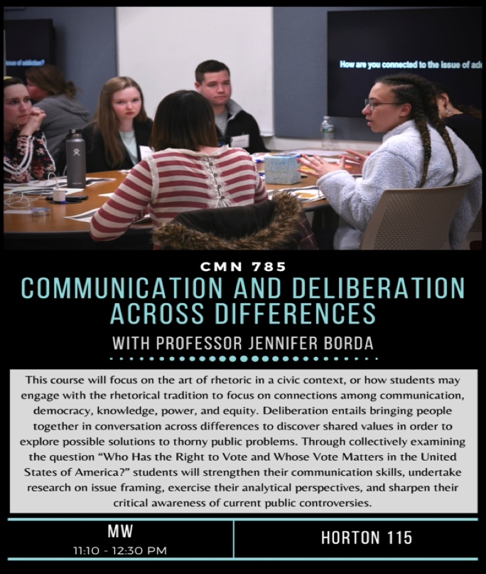
Fall curriculum in Professor Jennifer Borda’s Communication and Deliberation Across Differences, CMN 785 seminar, fittingly focused on Voter Rights. During the semester, students participated in a values exercise regarding their understanding of the right to vote, explored their own points of view and alternative views on access to the vote, and learned to complicate the narrative about who gets to vote and how. Students in the class also participated in experiential learning activities throughout the semester, including as participants in a forum on Free Speech and the Inclusive Campus with Intro to Civil Discourse Students (CMN 540), and by attending either the CDL’s Access to Higher Ed forums or joining virtual Common Ground for Action forums on a variety of topics.
The spring seminar Public Dialogue and Deliberation CMN 662 engaged sixteen upper division students in the fourth annual Stories and Voices series taught by Professor Renee Heath. This year’s program partnered with the faculty from the Sustainability Institute to host three public dialogues that coincided with the timing and content of the 21 Day Habit Building Racial Equity Challenge. The events were held virtually and were designed to engage students peer-to-peer. Student facilitators from the course read deeply on racial equity, especially as it relates to US food systems. The three events were attended by UNH students, averaging forty participants per evening. Building on the content supplied by the Challenge, the April 8 event was themed around Acknowledging Indigenous People and their relationship to food and land. The second event, April 14, focused on Invisibility and Racism. The final evening, April 22, considered themes around Responsibility and Accountability.
Professor Reinig integrated teaching and research into her spring capstone seminar course, Understanding Civil Discourse, CMN 740. This course did the double duty of teaching eight students qualitative research methods and analysis while conducting a bona fide study of programs executed by the Civil Discourse Lab. Students did initial interviews of CDL alumni, however, the study was continued with Dr. Reinig and CDL Fellow Ashley Strokus. Preliminary results are presented later in this report as the study is on-going.
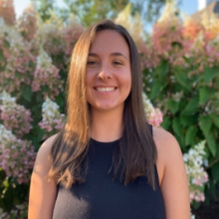
Retiring professors Sheila McNamee and Jack Lannamann, also taught courses that CDL students gravitated towards in an effort to round out their concentration. We will miss Dialogue and Teamwork, Mediation, and the Psychology of Communication as key courses in the CDL curricula, as well as our colleagues who taught them. Collaborative Leadership, CMN 562 and Introduction to Civil Discourse, CMN 540, remain in the curriculum as feeder courses through spring 2022.
Fellow Stephanie Rouse ‘21 led the Stories and Voices team on program design, content, and technology
Selected Publications 2020-21
advancing the Lab’s mission

Heath R.G., Borda, J. L. (2021). How will the conversation continue? Creating discursive openings in uncivil times. Deliberative Democracy Digest [Internet]. Publisher's Version

Heath, R. G. & Borda, J. L. (2021). “Reclaiming Civility: Towards Discursive Opening in Dialogue and Deliberation,” Journal of Deliberative Democracy, Vol. 17, no. 1 (2021): 9-18. doi: https://doi.org/10.16997/jdd.976

Heath R.G. (2021). Stories and Voices: Engaging community differences by designing a deliberative public dialogue. Communication Teacher Publisher's VersionAbstract

Borda, J. L. (2021). “The Embodied Maternal Rhetorics of Serena Williams,” Communication and Critical/Cultural Studies, Vol. 18 no. 2. https://www.tandfonline.com/doi/full/10.1080/14791420.2021.1905167?src=

Borda, J. L. (2021). “Rhetorical Legacies of the Opt-Out Revolution,” in Maternal Theory: Essential Readings, 2nd edition. Ed. Andrea O’Reilly (Bradford, ON: Demeter Press), Chapter 58, pp. 883-898.

Borda, J. L. (2021). “Workplace and Social Justice: A New Feminist Movement for Labour and Love,” in Mothers, Mothering, and Covid-19: Dispatches from a Pandemic, Ed. Andrea O’Reilly and Fiona Green (Bradford, ON: Demeter Press).

Reinig, L., Heath, R. G., & Borda, J. (2020). “Tendering Dialogue: Earnest Openings for Communication Across Polarizing Politics,” presented at the National Communication Association Annual Conference

UNH Center for the Humanities “First Mondays Series” (Jennifer Borda and Renee Heath), “Discursive Openings for Difficult Classroom Conversations.” December 7, 2020.

Pennay, A. (2021). The civic mission of museums. Rowman & Littlefield. Features our collaboration between UNH Museum of Art and the Civil Discourse Lab.

Panelists (Renee Heath and Jennifer Borda). At the Crossroads for Survival: Innovative Practices for Undergraduate Communication Programs. National Communication Association. Indianapolis, IN. November 2020 (virtual conference due to COVID-19).

An Authorial Voice
Increasingly, the work in the Lab is seeding academic publications and formal talks. Two articles published in this calendar year and one conference paper directly involved data produced from the Lab. Professors Heath and Borda theorized discursive opening as the primary purpose of public dialogue and deliberation in the international journal, Journal of Deliberative Democracy. Heath also codified the methodologies associated with the Public Dialogue and Deliberation Course in Communication Teacher, which highlights the pedagogical benefits of students designing and facilitating the Stories and Voices series. Finally, Dr. Reinig led a co-authored conference paper last November at the National Communication Association virtual meeting, that demonstrates the communicative strategies that students use when navigating contentious political conversations. This research suggests the importance of facilitated discussions, as the mere presence of student facilitators encouraged rich, civil discussions around disparate conceptions of freedom.
Additionally, Borda and Heath led a First Monday’s Series discussion for the UNH Center for the Humanities entitled “Discursive Openings for Difficult Classroom Conversations.” Heath opened the spring semester convocation with her talk on “Higher Education in a Democracy and the Praxis of Civil Discourse” and Borda presented “Reimagining Civil Conversation” to the River Woods Retirement Community. Lab faculty are cultivating an authorial voice on matters of civil discourse and have been invited to participate in a number of national panels and learning exchanges on the matter, including the Kettering Foundation Experiments in Deliberation Among Higher Education Institutions Learning Exchange Exploratory Meeting, and the Ithaca Initiative at the Joseph R. Biden School of Public Policy and Administration at the University of Delaware.

Enhance Student Success and Well Being
Calendar of CDL Events and Facilitations
Fall 2020
September Kickoff meeting
September Free Speech and Inclusive Campus forum
September Access to Higher Ed Pilot
September Black New England Conference
September Virtual Notetaking Training
October Art Museum “The Blues in Me”
October Access to Higher Ed Event #1
October We the People Performance Facilitation
October Access to Higher Ed Event #2
November Access to Higher Ed Event #3
November Voting Forum (CMN 785)
December Access to Higher Ed Event #4

Spring 2022
February Andy Coville “Creating Relevance”
March Art Museum “Nobody/Somebody”
March 21 Day Habit Building Racial Equity Challenge Facilitator Training
April Racial Equity Challenge (CMN 662) Event #1 Indigenous Acknowledgement
April Racial Equity Challenge Event #2 Invisibility and Racism in our Food System
April Racial Equity Challenge Event #3 Responsibility and Accountability
May Research presentations (Understanding Civil Discourse CMN 740)
May CDL Alumni Connector End of Spring Semester Event

CDL IMPACT STUDY LAUNCHED

Faculty designed a research project to measure student outcomes regarding the efficacy of the Civil Discourse Lab. Students in Dr. Reinig’s, Understanding Civil Discourse, (CMN 740), class were trained in IRB and qualitative methods. Students conducted interviews with CDL alumni to explore the possible impacts of their CDL experience and to help faculty to discern the separate efficacy of curricular participation (deep study of dialogue, collaboration, deliberation, and civil discourse), co-curricular (i.e., design and participation in events executed in an out of classes) and extra-curricular (i.e., participation in relevant events and lectures on campus). Additional interviews were conducted by Dr. Reinig and trained CDL Fellow Ashely Strokus. Faculty are still codifying the transcripts from more than 30 interviews, however early themes are emerging:

LEADERSHIP/JOB THEMES
- Listening skills
- Process design
- Question and agenda writing
- Program materials design
- Facilitation and conflict mediation
- Problem solving

For the past several years, anecdotally, alumni were reporting that their CDL experience had made a difference when interviewing for jobs. Early review of the qualitative data suggests this theme holds true. Other qualitative themes indicate specific skills that former students (and/or their employers) identified as important to the job market that include listening, process design, question formulation and agenda writing, materials design, facilitation and conflict mediation skills and problem-solving. What was surprising to us is that former students reporting this success were not necessarily part of the leadership team, (such as students who received fellowships, or were hired as the Assistant Program Director). Indeed, students we call “Affiliates,” who were free to participate as much or as little as they wanted without cumbersome obligations, also reported similar success. That said, greater participation is linked to perceptions of crossover skills.

“The job I have now that I got, both of the companies [I applied to] were like, ‘this is insane. This is so awesome that you're- you have people skill. You can facilitate, you can run an agenda, a meeting, dealing with conflict and you're a problem solver.’ Like all these skills that I would talk about, they were ‘Oh my God, like that's great.’ So, I think that is definitely the biggest impact. Just talking about the experience. A lot of the questions I get during interviews are like situational questions. ‘So, when were you confronted with the problem?’ But like, ‘What did you have to do to like solve it?’ Like those types of questions. And a lot of- a lot of the questions I was relating to like, ‘Oh, I was in charge, I was a part of the team to plan this like to be 100-person dialogue.’” - Male Fellow ’20, Marketing

“I really think the process of creating, the process of creating an event and organizing the event. Organizing Stories and Voices was hugely beneficial to me. So, I actually spoke about that process in every single one of my job interviews and every single one of my conversations with just career professionals that I had been introduced to. I leaned heavily on Stories and Voices and the process of doing the research. Doing the learning beforehand, you know, creating the program, interviewing people. And finally, you know, I had to let them know. We didn't get to execute, unfortunately, to the full extent, but that has been my most, you know, that has been my most beneficial part of my participation in CDL is, it gave me legitimate experience, without it being necessarily work experience, but it is relatable. And, you know, people who I've spoken to have responded really, really, well to that, to that process. Again, you know, that process as well allowed me to create the initiative that [name] and I co-created at UNH. I think we had the tools in our arsenal to be able to facilitate something like that and pull together all the people that we needed to. So, I think, just in hope- in big picture, the entire process of planning an event like that and learning how to facilitate, I think really helped me. -Female Affiliate ’20 Community Organizer

“I definitely think I got my first job out of college because of CDL, they asked me a ton of questions about it, and I think I did three or four interviews, every single interview they asked me questions about the CDL and my experience with it. And I think just like facilitating the two different events I did made me just like a little more confident talking to older people, cause that I'm the youngest person by like 10, 15 years usually at the City Hall so just having an experience with like the public and these random people help definitely…I just think specifically at the City Hall that it was actually applicable like, ‘Hey, she's done minutes, hey, she's made agendas,’ and just like my communication classes in general, they were asking me questions about it and just being, you know, being able to talk and then write too.
First Year Affiliate, Female ’18, City Planning Officer

“Yeah, I think it didn't take me until recently this past winter to realize the skills that I had learned, but I'm in law school right now and I've been applying and have been applying from November to last month for jobs for the summer. And I've been applying to a lot of public interest jobs with family law, children law, immigration law, stuff like that. On a lot of the applications that I was submitting, they would put that we want candidates who are able to work in an environment with a tougher, difficult thing to talk about or people who have experience, like managing difficult conversations that aren't the easiest to talk about. It was actually something that I got asked about in interviews because in my cover letters and during interviews, I would talk about the Civil Discourse Lab and how we did the Stories and Voices of immigration. Then the second year it was about a substance abuse…Those were difficult things to talk about and how the CDL prepared me to be able to have those conversations in real life. And so in cover letters or interviews, I would talk about how those skills kind of translate to things in the real world, and while I was having those or doing those facilitations in the CDL, I didn't realize it until I saw it, employers looking for that. And I was like, ‘Oh that is something I know how to do and something I feel comfortable doing. I think that's the other biggest thing that I took away from it that took me a while to put together. But it's definitely been extremely helpful now being on the other side of it.” -Female Affiliate ‘20 Second Year, Law School Student

“…without a doubt in my mind-like I know it was probably the main driving factor as to why I did receive the position that I did. Since then, I have been able to be promoted twice now. Once from a training intern to an actual trainer and I actually just got promoted at the beginning of the month to a trainer too-so, everyday using the skills that I learned in the CDL-those project management skills-I'm just thankful I took that course my senior year when we did the event-because those skills are truly used in my every day-in the position that I'm in. I’m just so thankful that the program came about, and I think that this is such an awesome opportunity. Female Fellow ’19, Learning Development Trainer

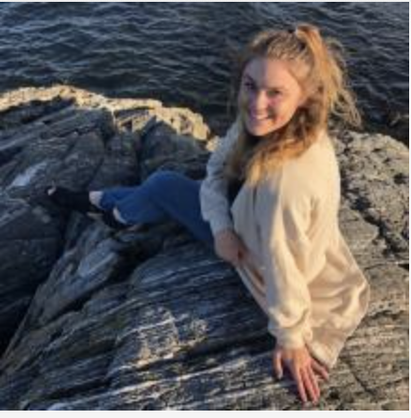
LIFE SKILL THEMES
- Empathy
- Embrace discomfort
- Perspective taking
- Curiosity

In addition to work skills, former students remarked on the impact participating in the CDL has had on their personal lives. A surprising, ubiquitous theme has been a greater willingness to be uncomfortable. As well, alumni saw changes in the way they have come to understand people, the ability to empathize, be curious, and see another perspective as reasonable.
Ashley Strokus, Fellow ’21 and Lead Student Researcher

“Well, the CDL kind of changed how I perceive my entire life. I mean, that's going to sound pretty hefty at first, but like I said, I was- I went into college right out of the military. I was a sheltered kid before the military. And then my ideals from one state to the other- were very [centrist], like, there's nothing to the left or right. Just live your life, get through it, and get over it. And then going through this CDL course was like- going through the CDL- the courses that were involved it and just talking to the people was eye opening- to just realizing that there's more to it than just surviving yourself, and only understanding yourself.
-Male Affiliate, Nontraditional student ’19, Marketing

PEDAGOGICAL THEMES
- Strong faculty /alumni relationships
- Increased understanding/interest of major
- Regret not getting involved sooner
- Reliance on faculty coaxing, extra credit, or co-curricular credit to initiate involvement
- Flexible participation and hour accumulation motivating
- Peer-to-peer influence important
- Debriefs key

Finally, several themes have surfaced regarding pedagogy especially as we seek to understand the relationship between curricular, co-curricular and extra-curricular activities. Unsurprising are themes around building strong relationships with faculty, becoming more interested in the major, and appreciating flexible ways of participating. Perhaps more surprising is how important explicit invitations by faculty, and extra and co-curricular credit (required participation in initial projects) have been in convincing students to participate. Ironically, one of the more expressed thoughts has been students regretting that they did not get involved sooner in their first few years. Despite hearing about it from faculty for several years, often participation hinged on a personal invitation or extra credit experience.

“I feel like just because it was my senior year, it was the last semester, it was really the homestretch. I like had zero motivation to do anything. Honestly, and that class was really just something I actually look forward to going to every day, it was one of the classes that I felt like every reading she assigned us was super-super relevant and like assisted us in our capstone project. And just the fact that like we had, we were working in small groups we come together as a class. It was just structured really-really well and I think that, as a whole, combined with just being my senior year and like looking forward to going to class like weirdly enough was just really great. – Female CDL Affiliate ’19, Recruiting Coordinator Amazon

So, the CDL was definitely like more of a focused [then other campus groups]. Kind of intimate feeling in, terms of the relationships, with other people, in the lab and the facilitators, professors. So, I'd say-it was definitely a bit more interactive and like I said, a bit more-equal-uh-in terms of like no higher like traditional hierarchy within it. And collaborative. -Female CDL Affiliate ’19, Account Executive Public Relations

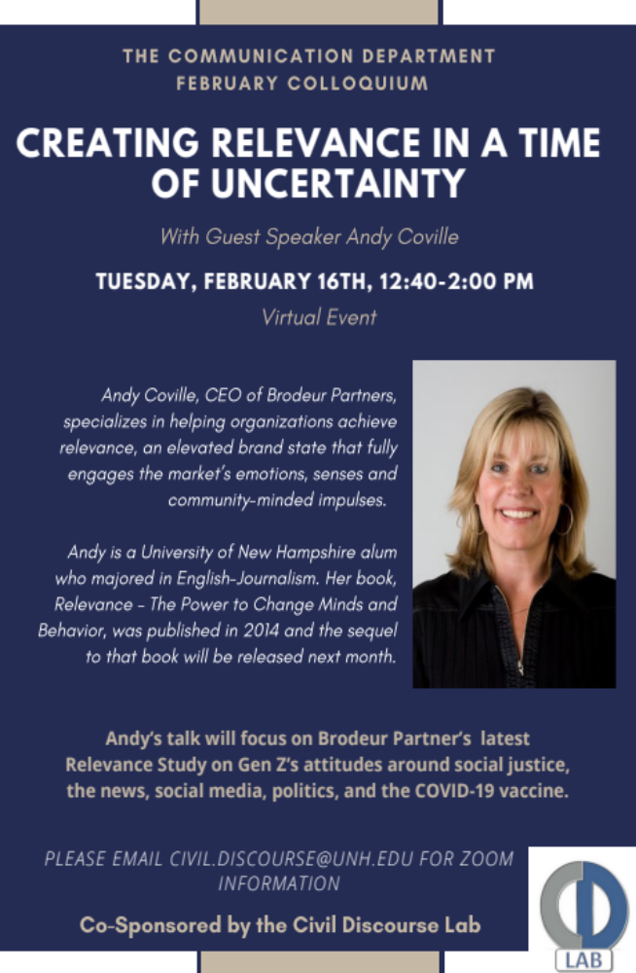
The relationships among themes are presently still being fleshed out. Clearly alumni appreciated the many different avenues in which they were able to participate. They also note being able to learn from their peers through experiences such as participating in a dialogue, or notetaking, before facilitating on their own, was an important learning opportunity. Finally, of all the pedagogical experiences intentionally created for the CDL from attending campus lectures, to designing facilitations, we were surprised to learn how meaningful the debrief meetings after events were for students as learning opportunities whether they felt they had done well as a facilitator, or not. We suspect debrief meetings were empowering for students, which does surface as a theme. The study begs several questions we hope to answer such as the relationship between hours of participation and outcomes.

One finding indicates students value the opportunity to learn from and meet outside speakers, such as our own UNH alumna Andy Coville, who just happens to be a huge supporter of the CDL! This research continues to track alumni and will proceed with interviews and analysis throughout the 2021-22 academic year.

CDL Sponsor Andy Coville, ‘82, Author and CEO of Brodeur Partners continues to foster connections between CDL and work

Embrace New Hampshire

IN A COVID WORLD
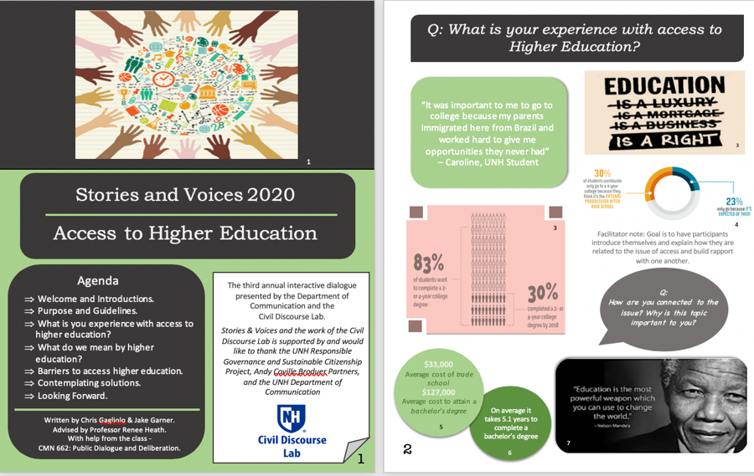
The year began with the organization of several deliberative events centered around Access to Higher Education. This work was a continuation of the Stories and Voices project begun in the spring 2020 Public Dialogue and Deliberation course. Because that course was not able to execute the public forum designed by students, CDL faculty and fellows restructured the event for a virtual format and held four fora on Access to Higher Education embracing various stakeholder groups throughout the state.
A total of 35 participants including UNH students and staff, academic counselors, community college students and nontraditional students convened on one of four nights in a facilitated Zoom meeting to discuss barriers and solutions. A full report of the outcomes of those meetings was written by CDL Assistant Program Director Piper Gibson, and can be found on the CDL website under the Reports tab:
(https://cola.unh.edu/communication/opportunities/civil-discourse-lab).

ART SPACES AS “THIRD PLACES” FOR CIVIC CONVERSATION
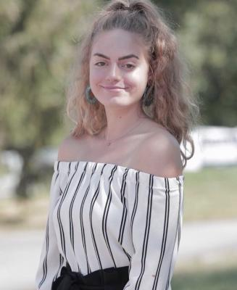
Throughout 2020-2021, the CDL continued pursing possibilities for visual art exhibitions and performances to catalyze civic discourse about contentious social issues. In Fall 2020, CDL Fellows Elza Brechbuhl and Stephanie Rouse guided a post-performance discussion following UNH’s Department of Theater and Dance ‘devised performance’ of “We the People.” “We the People” involved “a series of vignettes centered around our current social issues and one’s individual responsibility in our society” with the intent to “tackle uncomfortable but necessary conversations we as a nation need in our community.” CDL-designed discussion questions invited the audience to consider shared meanings created by the performance and attended to timely issues including social protest, the role of social media, systemic racism, white privilege, and microaggressions.
In collaboration with UNH’s Museum of Art (MoA) and under direction of CDL faculty, Fellow Alexa McNamara designed and facilitated two community conversations about MoA exhibitions. MoA’s “The Blues in Me: Witnessing Love” engaged themes of African American experience as explored in works of artist Enrico Riley, which embraced imagery depicting injustice, precarity, and diaspora. The 60-minute virtual forum was held October 15, 2020 and attended by six participants. MoA’s “Nobody/Somebody” explored themes of race and ethnicity, gender and identity, migration and immigration, and ability through portrait photography curated by Kristina Durocher. This conversation was attended by seven participants, including UNH students, community members, and a UNH MoA Board Member. The 60-minute virtual forum was held March 4, 2021.
Elza Brechbuhl Fellow 2020-21, Lead “We the People” project
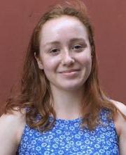
Integrating practice with undergraduate research, Alexa McNamara’s honors thesis, (advised by Dr. Reinig), Art Spaces as Third Places for Everyday Political Talk, drew on ten qualitative interviews with museum curators and artists. Alexa concluded that visual representations, environmental configurations, and facilitations play a key role in catalyzing discussions of contentious social issues within art spaces. Alexa presented her insightful analysis at the Spring 2021 Undergraduate Research Conference.

UNDERGRADUATE AND FACULTY RESEARCH COLLABORATION
This work led to an ‘innovation-in-practice’ paper submission to the National Communication Association, which was accepted for presentation in November 2021 (Reinig, Borda, & McNamara). Based on cumulative efforts to catalyze dialogic and deliberative conversations in the context of university creative and performing arts centers, Reinig et al. will present a template for forum design and propose that art museums/galleries and theaters can serve as ‘third places’ for civic conversations while also fostering high-impact student learning—specifically, offering alternative modalities for cultivating deliberative pedagogy on campus.
Alexa McNamara, Fellow 2020-21, Lead Museum Projects
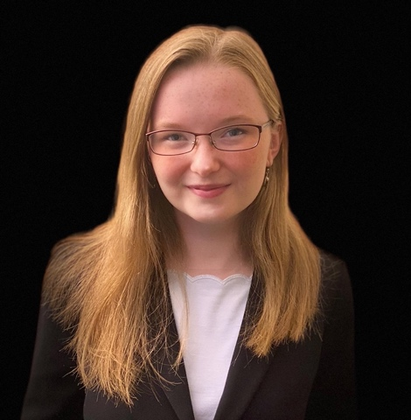

Congratulations Piper Gibson ’21, Incoming UNH Law Student!
Piper Gibson is our longest serving Assistant Program Director (APD). We leaned on Piper for three semesters. Two of those three meant mastering rapid changes due to Covid-19 and pivoting to on-line forums. Quite frankly, we don’t think we could have done it without Piper and the stability her position brought to the Lab. Piper came to us with a dual major in Philosophy and Political Science. She immediately started participating in Lab events, attending meetings and extra-curricular trainings. She even asked to audit lectures in our Public Dialogue and Deliberation course in an effort to be ready to facilitate Stories and Voices Engaging the Stigma of Addiction ’19. Piper, arguably has been our most prepared APD given her opportunity to be associated for all her years at UNH and to serve as a fellow before taking the helm of the Lab. She has left an indelible mark on our program by quickly learning and implementing marketing, hours tracking, program design, peer training, and the countless other things we ask our Fellows and Affiliates to do. Piper will now focus her immense talents on a law degree, at the University of New Hampshire, and we could not be prouder.

Build Financial Strength

BUDGET
The Lab’s budget was primarily supported through the Responsible Governance and Sustainable Citizenship Project (RGSCP). These funds allowed for three years of funding ($10,000 per year, fall 2018-spring 2021) that enabled us to grant three fellowships per semester for up to $500.00 to students who take on extraordinary responsibility with the Lab. Funds from the COLA Dean’s Fund also supported the work of Fellows. Additionally, funds ($5,000 annually) from UNH Alumna, and COLA Alumni Board Member, Andy Coville, (CEO Brodeur Partners), support the student Assistant Program Director, who is the righthand administrative arm of the CDL. Funds from these benefactors also support departmental assistance from the CMN department’s office administrator, allow for meals to be served at events, and aid in the marketing and promotion of CDL work. RGSCP funding does not carry over into subsequent years. Coville Funds carry over, but spending was frozen with the disruption of Covid-19.
The CDL was fortunate to continue to employ a Postdoctoral Research and Teaching Associate, entirely funded by the RGSCP. Dr. Reinig’s appointment will conclude at the end of the 2021/22 academic year. Her efforts to support CDL teaching, research, and service were invaluable this year. At this time, we do not have the faculty time or capacity to seek grant funding that could continue this position or other CDL work. Most of the tremendous time commitment of capacity building, grant-writing, designing, training, logistical support, and assessment of the work has been contributed as an overload to the teaching, research, and service duties of two faculty. None of the funds awarded to the CDL support the faculty administration of the program. The CDL seeks funding to provide a sustainable infrastructure that will carry this work beyond the individual efforts of faculty. With the cyclical ending of the RGSCP grant, we will be able to fund student fellowships through the 2021-22 year.

THE TEAGLE FOUNDATION GRANT UPDATE
The Lab experienced success winning a planning grant with the Teagle Foundation (’19). In anticipation of a follow-on implementation grant opportunity, several professors across departments and in schools at UNH prepared to collaborate on a cluster of classes that centered around a CDL 2-credit course that would make space to discuss and coalesce civic themes introduced in the courses. However, the next stage of Teagle Funding requires a systemic commitment to civics education from the University, in order to have the broadest funding impact. Given the on-going review of the Discovery curriculum, and the recent retirements of faculty in the Communication Department, we decided we did not have the capacity to pursue the implementation grant at this time. We remain hopeful that Lab work can be integrated more fully into the curriculum providing the broadest possible reach to UNH students across majors. Thank you to the creative administrators and teachers who shared our vision for greater collaboration across disciplines on subjects of civic importance.

MODIFICATIONS GOING FORWARD
Congratulations to our outgoing Fellows Alexa McNamara, Stephanie Rouse, and Ashley Strokus! With Professor Borda on sabbatical spring 2022, the CDL will run a modified version of its work with students. Many of this coming year’s programs will be executed as co-curricular activities where preparatory work will happen in the classroom. Given uncertain support, volunteer student facilitators will be recruited out of relevant courses such as Collaborative Leadership CMN 562, Introduction to Civil Discourse CMN 540, and other upper division courses previously named in this report. Though it is our desire to serve the University student population more broadly, it is not possible in our present capacity. The directors anticipate the extra-curricular model will not continue after the 2021-22 academic year. We remain committed to providing enriching opportunities for UNH students through this year. Students not in the Communication major but who have a desire to be involved are encouraged to take our courses. Tracking of students’ hours in lectures and trainings not conducted by the CDL will continue through this calendar year. Throughout this journey and as we close out this initiative, we are grateful for the support and partnership of our UNH and community partners.

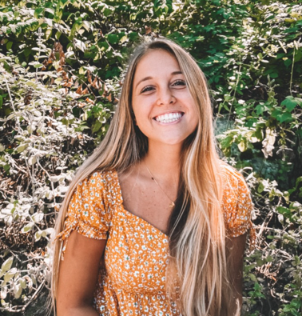
MEET THE 2021-22 LEADERSHIP TEAM
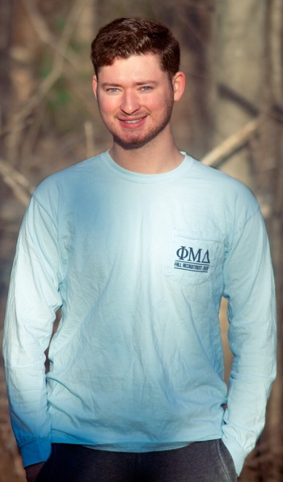
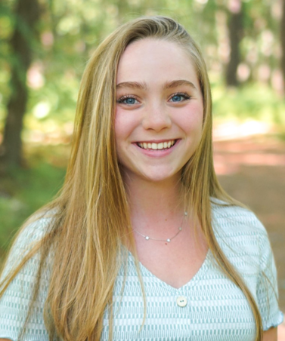
Paige Verrillo (left) is a senior studying Communication and media practices. She is excited to begin her work as the Assistant Program Director for the CDL for the 2021/22 academic year. She enjoys exploring around New England and finding a coffee shop or two along the way. Paige O’Neil (right) is a sophomore Communication student, a surfer, and skateboarder with a love for action sports and mental health outreach. One of the things she most looks forward to at UNH is being able to study abroad in Spain. She will serve as Fellow in the 2021 fall semester. Jonathan Goldberg, a senior Communication major with a minor in Law, is from Hopkinton, Massachusetts. Jonathan is the president of his fraternity, a student advisor for the UNH Community Standards office, and has plans to attend law school.

cdl Faculty and staff
Jennifer Borda & Renee Heath, Co-Founders, Co-Directors, Department of Communication
Lydia Reinig, Postdoctoral Research and Teaching Associate, Civil Discourse Lab
Assistant Program Director: Piper Gibson
Fellows: Elza Brechbuhl, Alexa McNamara, Stephanie Rouse, Ashley Strokus
Administrative Support: Kathleen Simoneau.

This report was written by Renee Heath, with Jennifer Borda and Piper Gibson, Summer 2021
Like us at https//www.facebook.com/UNHCivilDiscourse. Follow our website:
https://mypages.unh.edu/civildiscourselab.
Join us on https://www.linkedin.com/company/64266024/admin/

