Presented by:

The University of New Hampshire Department of Communication
The UNH Civil Discourse Lab
Written by: Piper Gibson
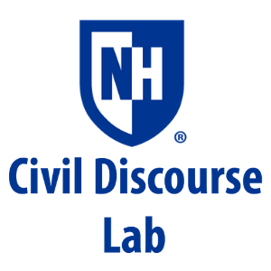

Stories & Voices
Access to Higher Education
2020-21 Evaluative Report
[Document subtitle]
Executive Summary
OVERVIEW
Event Dates: Oct 5th, Oct 22nd, Nov 9th, Dec 1st, 2020
Participants: 35
Represented Groups:
- UNH students
- Community college students
- Staff of UNH student support services
- Academic counselors
- NH community college staff
- NH community college Professors
- Non-traditional students
Structure:
- 4, 1 ½ hr. virtual events over zoom
- Each discussion included 7-8 participants (Oct 22nd event ft. 12 participants in two breakout rooms)
- One moderator, one notetaker, one recorder, one facilitator per event (Oct 22nd event ft. one notetaker, recorder and facilitator per breakout room)
- Ground rules were negotiated and agreed upon by participants
- Participants consented to have discussions recorded and used for research
- Prepared program guide for participants and facilitator script guided discussion
FINDINGS
Meaning & Role of Higher Education:
- When identifying forms of higher ed. participants cited obtaining a bachelor’s degree, an associate’s degree, and going to trade school an equal amount of times
- Participants’ valued higher ed. as a way to open doors in their lives
- Participants personal understanding of higher ed. and the meaning they gave to it changed after they left higher ed.
- Higher ed. provides the freedom to choose more options in life, but due to societal pressure to pursue higher ed., it can feel as though there is no freedom from higher ed.
Barriers to Accessing Higher Education:
- Financial barriers including high in-state tuition, loans, and a lack of financial knowledge prevent people from accessing higher ed. or suffering financially because of it
- Family obligations and socio-economic status inhibit people from accessing higher ed.
- Lack of knowledge about the application process and different higher ed. options prevents people from applying to higher ed. or knowing all available variations of higher ed.
- Inadequate resource allocation regarding internet access, school supplies, disability services, etc. complicate access to higher ed.
What’s Working:
- Pathways Program helps NH community college students obtain a bachelor’s degree
- The Running Start Program helps high school students earn college credit in high school, saving time and money
- UNH programs such as SAS, PACS, OMSA, and SHARPP helps support UNH students
What’re We Dreaming?:
- Making state schools more affordable would help many NH students
- Participants felt that a connection between businesses and higher ed. could help make higher ed. more affordable and applicable to the workforce
- Increasing financial literacy before, during, and after obtaining higher ed. would help increase access to higher ed. and improve the financial situation of many students
- Creating better connections between institutions of higher ed. and high schools would better support students in making educated decisions about their higher ed.
- Ending the social stigma against community colleges and trade schools would help normalize different paths to higher ed.

CALL TO ACTION
- Institutions of higher ed. should help inform high schoolers and the general population about the merits of obtaining higher ed., the value of different variations of higher ed. (e.g., community college & trade school), and the programs available to help support students access to higher ed. and ability to thrive while obtaining a higher ed. degree
- Corporations should invest in higher ed., either by contributing to institutions of higher ed. or by helping their employees gain an education/ pay off the education they have already received, to support their employees and the general workforce
- High schools should strive to support their student’s success in higher ed. by providing classes on financial literacy, helping students apply for aid and scholarships, and presenting multiple forms of higher ed.
- The social stigma, including within the workforce, against community colleges must be addressed
- State universities should partner more with community colleges to help support community colleges, provide community college students with more opportunities that are only available at a larger university, and to encourage community college students to transfer to a state university and streamline this process
- The social stigma against trade schools must be lessened and the value of trades, as well as the financial stability jobs within the trades can offer, must be acknowledged
- The admissions process should be transparent about the use of diversity and socio-economic questions on applications
- Decision makers should target funding for education to youth in areas of need (e.g., inner city & rural environments) to help support education from the beginning
- Decision makers should reallocate funds to help decrease the cost of state institutions of higher ed., both community colleges and state universities

PURPOSE
Stories and Voices: Access to Higher Education was planned to be an in-person event at the University of New Hampshire in Spring 2020. Theories of public dialogue, interviews of important stakeholders and people with unique experiences with higher education, and a comprehensive program guide was created by the Public Dialogue and Deliberation class taught by UNH Department of Communication Professor, and CDL co-founder, Dr. Renee Heath. Unfortunately, the onset of Covid-19 in March of 2020 led to the cancelation of the in-person event. In Fall of 2020, the Civil Discourse Lab, in partnership with the UNH Department of Communication, took the materials created by the Public Dialogue and Deliberation class and pivoted the event from one large in-person event, as originally planned, to four small online dialogues. The dialogue was planned, designed, and facilitated by professors and students involved in the Civil Discourse Lab. The purpose of the event was to determine the meaning and role of higher education, both on a personal and societal level, identify barriers that prevent people from obtaining higher education, and brainstorm potential solutions and dreams to address these barriers. Our hope is that the information, perspectives, and stories shared within these dialogues and that are captured within this report will help inform decision makers and increase access to higher education, specifically in the state of New Hampshire

METHODOLOGY
Stories and Voices engaged students and the public in a discussion on access to higher education with the goal of encouraging personal storytelling and fostering dialogic moments; not merely a back and forth exchange, but rather a relational interaction that involves mutual understanding of experiences built by listening to those involved. The event program and facilitation script guided participants through a deliberation regarding the value and meaning of higher education, barriers to accessing higher education, and evaluating current and hypothetical programs addressing access to higher education. We believe that if we allow citizens an opportunity to discuss the various interactions that make up the system in a nonpartisan environment built on respect, mutuality, listening, and agreed upon ground rules; then the result will be productive communication that leads to creative solutions.
Event Personnel Roles
Moderator: Dr Lydia Reinig served as the event moderator for all four virtual events. The role of the moderator was to introduce the event, the Civil Discourse Lab, and the student leaders facilitating and note-taking for the event. Additionally, the moderator familiarized participants with the dynamics of a virtual dialogue and the research project the Access the Higher Ed. discussions were part of. The moderator also managed the recording of the event.
Facilitators: Each virtual event had one or two student facilitators, depending on the number of participants attending the event. Facilitators were chosen from the CDL student leaders who are trained and practiced in the art of facilitation. The facilitators utilized a script and active listening to guide the dialogue, while encouraging participants to use the event program guide for inspiration and insight on the topic.
Notetaker & Recorder: Each event had one note-taker and recorder per breakout room. Notetakers and recorders were chosen from the CDL student leaders who are trained and practiced in the dynamics of notetaking and recording for dialogic events. Notetakers crystalized and captured important themes in the discussion to be viewed by participants throughout the event as a reference. Recorders sought to type every word said in the dialogue to create comprehensive notes to be used for research purposes.
Program and Event Designers: The following individuals played an integral role in producing and redesigning the event, facilitation script, and program guide.
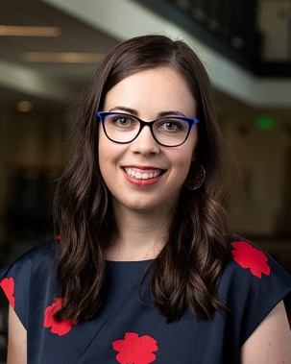
Dr. Lydia Reinig wrote the facilitation script for the virtual events, researched how to produce a productive and meaningful dialogue online, helped train student facilitators and note-takers for the event, and served as the moderator for the online events. Professor Reinig is a Postdoctoral Research and Teaching Associate at UNH. Her research explores public engagement, focused on how situated communication practices foster and constrain democratic action.
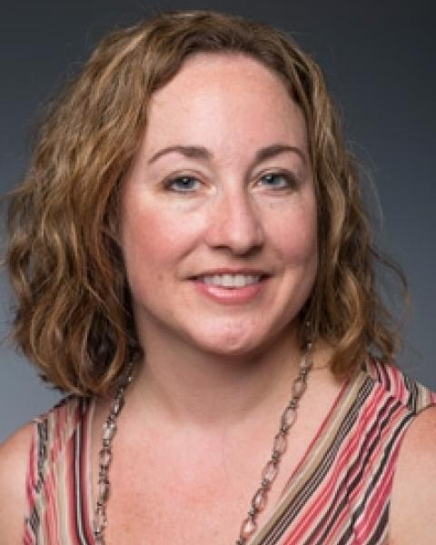
Dr Jennifer Borda helped oversee and plan the virtual events, served various different roles during the events, and helped advertise and recruit participants for the event. Professor Borda is an Associate Professor of Communication at UNH. Her research and scholarship specializes in rhetoric and public address, feminist studies, rhetorics of motherhood, and deliberative dialogue. Professor Borda is also the Co-Founder and Co-Director of the Civil Discourse Lab.
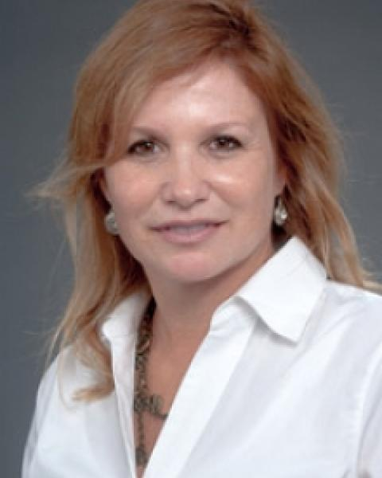
Dr. Renee Heath taught the Public Dialogue and Deliberation class in 2020 where she guided students through the interview process, researching access to higher ed., understanding theories of dialogue, and creating the program guide for the event. Professor Heath is a Principal Lecturer of Communication at UNH and is a scholar, writer, and teacher of shared decision-making in organizations, especially those collaborating across sectors to accomplish community-oriented goals. Professor Heath is also the Co-Founder and Co-Director of the Civil Discourse Lab.

Student Leaders: The following students helped plan, execute, facilitate, and note-take for the virtual events.
Piper Gibson is the Assistant Program Director for the CDL. Piper helped design, recruit and promote, plan, train note-takers, facilitate the virtual events, and write the evaluative report for the Access to Higher Ed series. Piper Gibson is a senior at UNH studying Political Science and Philosophy, with a minor in Classics.

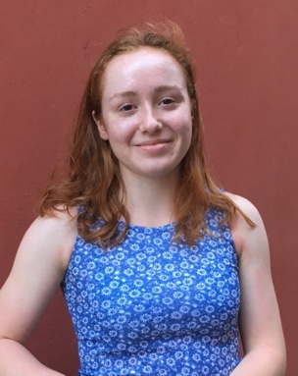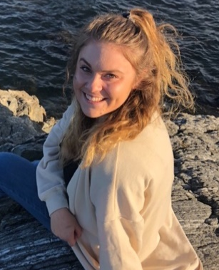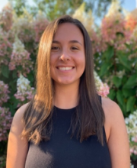
Alexa McNamara, Ashley Strokus, Elza Brechbul, & Stephanie Rouse (listed in order as pictured) are Fellows for the CDL who helped recruit, facilitate, and note-take for the virtual events.
Program Guide: The online events were guided by a program guide designed by students in the Public Dialogue and Deliberation Class under the advisement of Professor Renee Heath. The content of the guide was thoughtfully chosen based on the feedback, perspective, and stories shared by relevant stakeholders that were interviewed by students. The program guide consisted of facts and generative prompts about the meaning and role of higher education in society, barriers to higher education, as well as examples of current programs and ideas for future programs dedicated to increasing access to higher education. The program guide was used to help facilitate the discussion, guide the conversation to ensure that specific topics were discussed, and help participants generate thoughts.
Diversity: Before the events had to pivot to an online format, a significant amount of thought was put into who would participate in the dialogue. It was incredibly important that the dialogue’s participants were comprised of a group of stakeholders that had diverse perspectives, experiences, and voices. As such, students in the Public Dialogue and Deliberation class recruited participants from the community to represent a diverse spectrum of experiences and perspectives on access to higher education. After Covid-19 halted the production of this event and switched it to an online platform, reaching out to participants from a vast number of different perspectives grew more challenging. Despite this unforeseen complication, at each online forum a significant amount of diversity was represented. Furthermore, diversity was also represented in the content of the event program guide, which was inspired by interviews from a diverse group of stakeholders and utilized in the online forums.
- UNH Undergrad Students | - NH Community College Enrollment Specialist | - Representative from Pathways Program
- Community College Transfer Students | - NH Community College Professor | - Students from low socio-economic backgrounds
- UNH TRIO Staff | - Master’s Degree Student | - UNH Student Life Staff
- UNH Civic Community & Engagement Staff | - SNHU Military Academic Advisor | - Non-traditional Students
- UNH Academic Counselor | - UNH S.T.E.M. Advisor
Diversity Represented in Online Dialogues
Diversity Represented in Interviews for Event Program
- Students Entering Higher Ed. after Foster-care | - Students in the National Guard | - NH Community College Advisors
- Non-traditional Students | - International Students | - UNH Students
- High-School Guidance Counselor | - Students with Mental Health Illness | - Students from low socio-economic backgrounds
- UNH McNair Program Staff | - UNH Students
- 1st Generation Students | - Trades Representative

DYNAMICS OF ONLINE DIALOUGES
After pivoting the Access to Higher Education forum to four online deliberations, the CDL sought to retain the quality of the dialogue and the personal connections created between participants that occurred in previous in-person Stories and Voices events; however, recognizing the different dynamics present in an online deliberation, different methods had to be researched and implemented to maintain the quality of the dialogue, the creation of a space where participants could create meaningful connections, and the ability for the events to be further analyzed and used for research purposes.
Maintaining Quality of the dialogue while meeting the needs of an online forum was the first priority for the online Access to Higher Education events. To maintain the quality of the dialogue it was important to ensure that participants at each of the four dialogues had diverse backgrounds and perspectives on access to higher education. By doing so, participants could learn from one another, broaden their perspectives, and enrich the deliberative aspect of the forum. Diversity in the forums was monitored before the events took place by including the question “How are you connected to Access to Higher Education?” in the pre-registration forms participants filled out prior to attending the event. Answers to this question helped event designers assign participants into different breakout rooms prior to the event to ensure that each room included diverse perspectives and family members and friends were separated into different rooms when possible.
Preparing high-quality materials for the online deliberations, including the program guide, also helped maintain the quality of the deliberation. The program guide, as previously discussed, was created after extensive research and conducting and studying interviews performed by students of the Public Dialogue and Deliberation class. The program guide included facts on recent legislation concerning access to higher education, barriers that are salient to individuals trying to obtain a higher education in NH, generative prompts and quotes, etc. all thoughtfully included to raise the quality of the deliberation and inform participants. Unlike previous Stories and Voices events where participants were only given the program guide at the event, the virtual format of the Access to Higher Education deliberations provided the opportunity to send participants the guide prior to the event. This allowed participants to begin contemplating the topic, based on the guides’ promptings and included information, prior to the online events.
The facilitator script also helped maintain the quality of the event. The facilitator script was thoughtfully produced in such a manner that guided participants through introductory questions designed to put parameters around what we define as higher education, and to consider the purpose and value attached to higher education. This conversation then led to a discussion which guided participants to identify and discuss salient barriers to access to higher education. After barriers were identified, the script then helped guide facilitators to move the conversation towards how barriers to higher education are currently being addressed and how they should be addressed. The facilitator script helped support facilitators through these transitions and conversations, while also allowing the facilitator enough freedom to cater the dialogue towards the individual interests of the group. To determine the effectiveness of the facilitator script, the script was practiced and refined in a mock-event with CDL members prior to the four deliberative events.
Creating a Welcoming Space for Dialogue was also an important consideration during the designing process of the event and throughout each of the four dialogues. Creating a welcoming environment invites participants to share their stories, connect with one another, broaden their perspectives, and engage in productive deliberations on sensitive topics. Online spaces can make it harder for participants to feel connected to one another, encouraged and welcomed to participate in the conversation, and engage in respectful practices to ensure the civility of the dialogue.
To help create a virtual environment where participants felt comfortable and encouraged to participate in the dialogue, and to ensure the dialogue retained its meaning and significance, ‘zoom rules’ were introduced by the event moderator. Zoom rules included having participants mute their microphone when they were not talking, turning their camera on, and suggesting that participants use gallery view so they could see all participants in the breakout room at one time. Having participants turn their microphones off and keep their camera on helped ensure that participants felt engaged in the conversation and were not distracted. Participants were encouraged to use gallery view to mimic the experience of sitting around a table in-person and to ensure that the participants felt connected to one another. Additionally, a style of turn taking called ‘pass the ball’ was explained to participants and utilized throughout the dialogue. This technique involves one participant speaking, and then ‘passing the ball’ and naming another participant to speak. This practice helped participants feel welcome in the conversation, comfortable talking, and took the place of the common practice in in-person dialogues of going around the table and having each participant speak in order.
- Be authentic, inclusive, and respectful in your engagement | - Share speaking time so everyone has an opportunity to participate
- Uphold and appreciate the participatory process | - Maintain confidentiality and avoid generalizations
- Practice gracious and constructive disagreement | - Listen to appreciate another’s perspective
To create a virtual environment that encouraged respect and civility, the following ground rules were introduced by the facilitator in the beginning of the conversation.
After the ground rules were introduced by the facilitator, they were discussed and agreed upon by participants. If desired, participants could add upon the rules or revise the existing rules to meet the needs of the participants.
While the main strategies for creating a welcoming space for dialogue included the use of zoom rules and conversation ground rules, other practices of facilitators and other event organizers helped create this space. Practices such as personally welcoming each participant and conversing with them before the beginning of the event helped create a connection between the participants and helped decrease the artificial atmosphere of the online environment. Additionally, facilitation techniques such as being comfortable with silence in the conversation while individuals gathered their thoughts and cold-calling participants who were less talkative to welcome them into the conversation, helped create an environment for a meaningful and inclusive dialogue.
Maintaining a Connection to Research was also an important consideration during the design process of the four online dialogues. Previous Stories and Voices events have been summarized into reports that have been given to stakeholders and changemakers. For instance, the Stories and Voices event in 2018 entitled “Engaging the Stigma of Addiction & Stories of Hope” was part of a research initiative that involved analyzing the dialogues that occurred during the event and crystalizing the information and perspectives shared by the participants into a report. This report was then sent to local police forces, related non-profits, and other important stakeholders and changemakers throughout New Hampshire to be used as an informative guide on matters related to opioid addiction. The CDL felt that this follow-through was an important aspect of the Stories & Voices event that should be valued and continued in the pivot to an online format.
To ensure that the online forums on Access to Higher Education could still be used for research purposes, several changes had to be made to the logistics of the events. In past years, recording devices were used to capture each table’s dialogue and note-takers crystalized the conversations at each table; however, this process was much easier and more effective online. With the permission of all participants at the online forum both prior to the event and during the event, the forum was recorded and saved for research purposes. In addition to the recording, the CDL recorder took verbatim notes to provide more detailed records of the conversation. Lastly, a note-taker took crystalizing notes online that could be viewed by the participants during the deliberation and for research purposes after the event. The combination of these three techniques captured the dialogues in such a manner that research analysis can be produced that authentically captures the viewpoints of the participants.

UNDERSTANDING THE MEANING & ROLE OF HIGHER EDUCATION
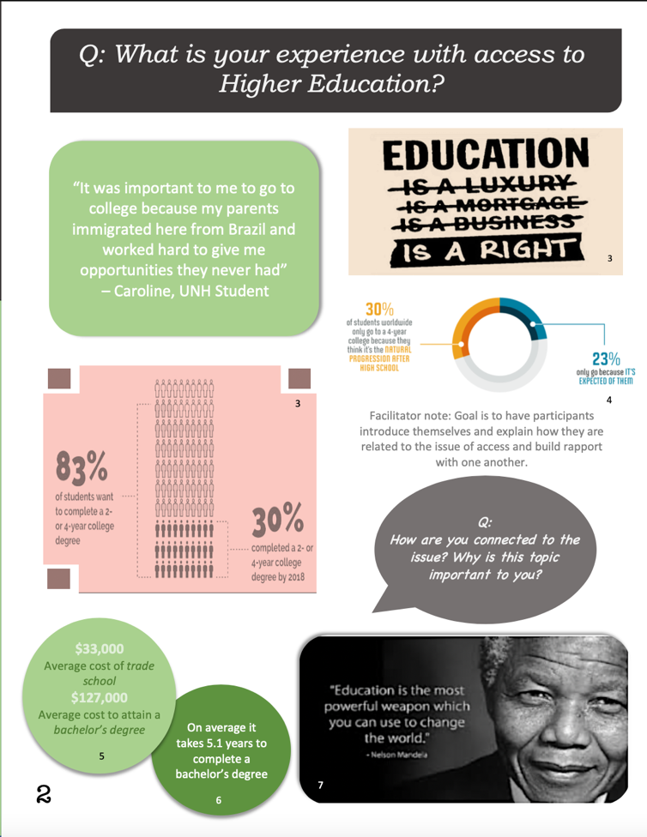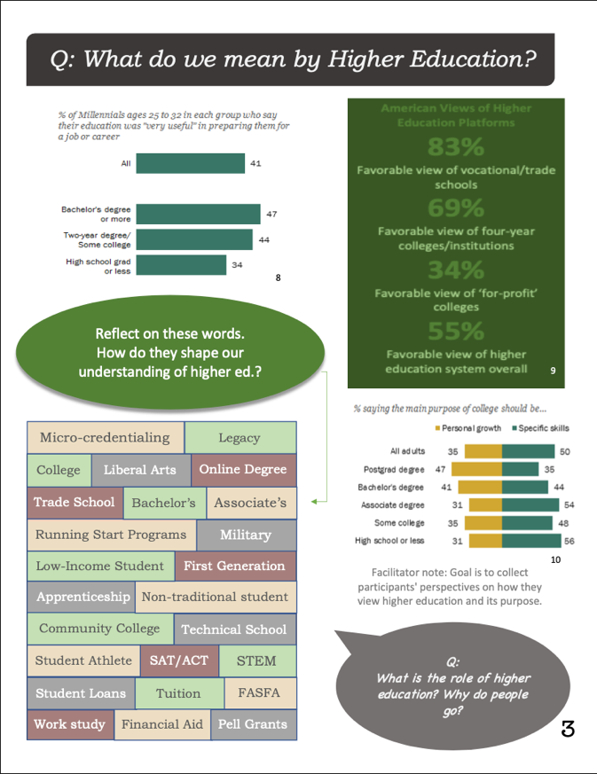
Higher education can take on many different forms, have different purposes and roles in someone’s life, and can be assigned different meanings both at the individual level and the societal level. As part of these dialogues, the CDL sought to identify what type of learning participants associated with higher education to determine participants’ familiarity with different types of higher education. We also hoped to unpack this question and determine if some types of education may be associated with higher education at a greater frequency than others. After introductions and having participants share their personal stories in connection to access to higher education, participants responded to this question by discussing different forms of higher education, such as four-year colleges, community colleges, trade schools, online schools, and college degrees obtained with military assistance; however, participants also identified a strong societal push towards associating a four-year college with the best form of higher education available. One popular theme in the discussions was participants citing personal stories of being pushed towards four-year colleges in high school and being presented with obtaining a four-year degree as the only option after high school graduation. As one participant recounts “it felt like high school did not give me an option to not apply to college- college was the only way.” Being presented with such a narrow view of higher education, especially during formative years in an individual’s education, limits an individual’s access to different forms of higher education and promotes the societal stigma against forms of higher education that are not four-year degrees.
After identifying different types of higher education and what paths to higher education are most frequently associated with the term, participants were asked to identify why people, including themselves, seek higher education. By including this question within the dialogue, the CDL hoped to gain insight into the participants personal reasons for obtaining or not obtaining higher education. This conversation also gave participants the opportunity to gain a broad understanding of the many reasons why higher education is sought after by learning from the exchange of one another’s stories. Participants shared that they sought higher education for practical benefits such as gaining more job opportunities, access to higher paying jobs, more chances to move up the career ladder, gaining problem-solving and critical thinking skills, and to switch from working a blue-collar job to a white-collar job. Less tangible reasons were also expressed, such as wanting more personal freedom and ability to dictate their own lives. Additionally, participants cited reasons related to personal growth, such as wanting to broaden their perspective on the world around them, learn more about themselves, and determine what path they wanted to take in life. By recognizing the various different reasons why individuals seek higher education, access to higher education and the skills taught at institutions of higher learning can be better catered towards these goals. Moreover, the pressure felt by individuals to obtain a higher education is represented in the goals expressed by the participants. By stating these goals, certain prevalent societal realities are identified, such as being unable to move up in the career ladder without obtaining a higher education, which can then be evaluated and scrutinized.
Questions:
- How are you connected to access to higher education?
- When we talk about ‘higher education’, what forms of advanced learned are associated?
- Why do people seek higher education?
- What is the value of higher education in your own life?
- What is the role of higher education in society?

Building upon the previous set of questions that determined the participants reasons for obtaining higher education, the next question asked participants to identify and deliberate on the role of higher education in society. In this section of the dialogue, the CDL hoped to have participants not only identify the role of higher education in society but to also critically analyze this role and compare it to the reasons they identified as to why they personally did or did not seek higher education. Reiterating the theme identified in the beginning of the previous section of the deliberation, participants stated that obtaining a higher education is viewed as a pinnacle achievement that individuals are put under a lot of pressure to earn. Although most participants agreed that the societal pressure to obtain a higher education has negative impacts, to some participants, the role of higher education in society is largely positive. Participants said that higher education is viewed by society as an equalizing factor that allows individuals to better their lives, is proof of a significant personal achievement, and as an option for people to shape their own lives. However, participants also stated that the current role of higher education in society separates people into majors and degree-hierarchies, can be a mechanism to maintain social class structures, and gives the unrealistic impression that gaining a higher education ensures financial stability. As stated by one participant “There is tension between what society needs and what an individual needs with access to higher education. We all want each other to rise and meet our gifts in the world. Some gifts and gifts in people are valued more than others. There is tension in what has most value and worth in our society.” This tension was also reflected in the personal stories of participants who shared that their personal reasons for obtaining a higher education were strongly influenced by the role and meaning given to higher education in society. By identifying the tension between personal reasons for desiring higher education and the societal role of higher education, this relationship can be further analyzed and individuals can become more aware of how the societal value given to higher education can influence their personal reasons for desiring higher education. Furthermore, the role of higher education can be evaluated and criticized by relevant stakeholders to determine whether or not the current role of higher education in society has a net positive or negative impact.
Call to Action:
- High school educators and guidance counselors should strive to educate students on a wide variety of different forms of higher education
- High school educators and guidance counselors should not give blindly give preference to certain types of higher education, specifically four-year degrees
- Decision makers should consider measures to increase public awareness and support for under-recognized forms of higher education, i.e., community colleges, trade schools, online schools, etc.
- Family members, educators, and community members should thoughtfully consider the value that they assign to higher education and if that value has a positive impact on members of society

BARRIERS TO ACCESSING HIGHER EDUCATION
Questions:
- What barriers to accessing higher education exist (throughout New Hampshire and at UNH)?
- What barriers have we not shared that you thought about and listed?
- What are some of the ways specific barriers are currently being addressed in New Hampshire and by UNH?
- What are some of the ways specific barriers are currently being addressed in New Hampshire and by UNH?

At this stage in the dialogue, the focus shifted to identifying and discussing barriers that prevent individuals from accessing higher education. To focus the conversation and increase the pertinence of the dialogue to the targeted New Hampshire audience, participants were asked to think of barriers that are prevalent in New Hampshire. While these included barriers to accessing higher education that are felt nationally, such as high tuition costs, participants were also encouraged to deliberate on barriers specific to New Hampshire, such as difficulties New Hampshire students encounter when transferring credits from a two-year college in New Hampshire to a four-year college.
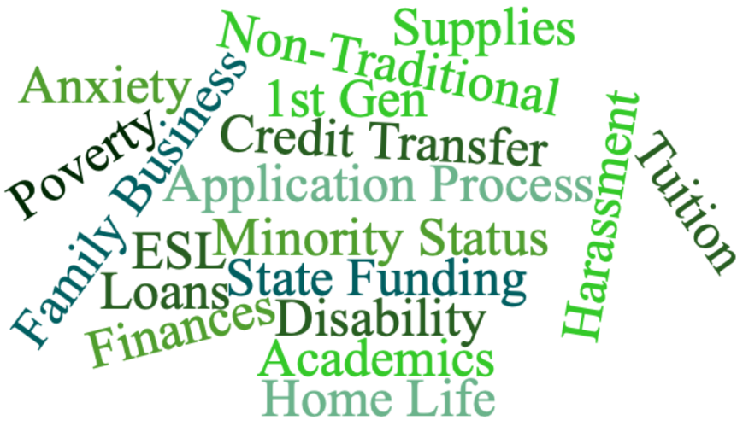
To begin this section of the deliberation, participants were given two minutes to create a list of a few barriers to accessing higher education that they deemed significant. Participants were encouraged to view the pages of the program guide dedicated to barriers to accessing higher education for inspiration. After given time to contemplate, participants were encouraged to share a barrier that they thought of and why they deemed this barrier to accessing higher education significant. Many participants used this opportunity to share their personal stories of why they, or someone close to them, struggled to access higher education. The barriers discussed included barriers that were financial, socio-economic, academic, and family-based. This stage in the deliberation allowed participants to find common ground with one another as they shared similar stories and also allowed participants to broaden their perspectives as they learned of barriers to accessing higher education that they had never previously considered.
Above is a selection of many of the barriers to accessing higher education that participants identified
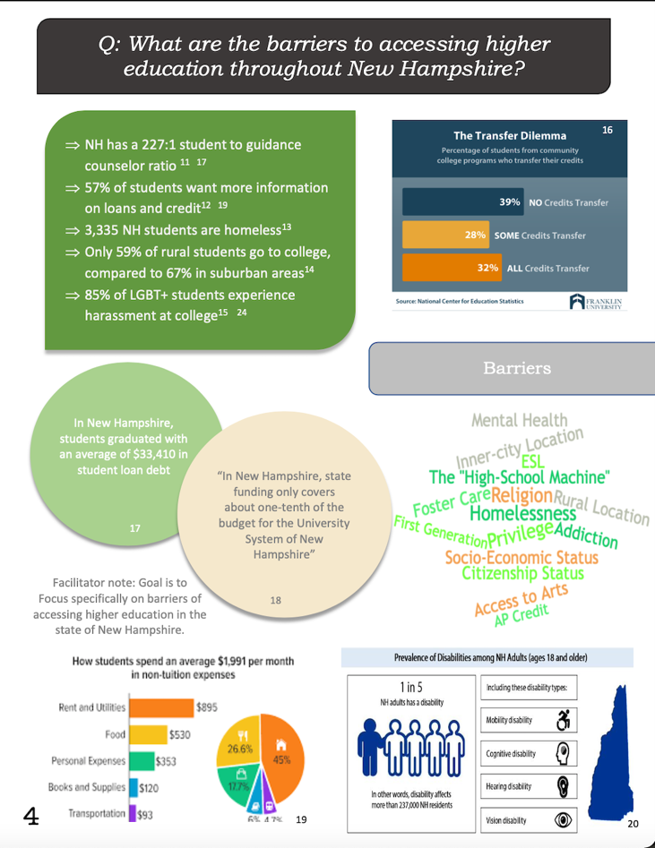
After identifying and discussing many different barriers to accessing higher education, a “hot lava” poll was used to identify one barrier to higher education to discuss for the last main section of the deliberation. Before the hot lava poll, participants were given the opportunity to view the crystalized notes taken by the CDL notetaker to refresh their memories on what barriers to accessing higher education had been discussed thus far in the dialogue. After allowing the participants a moment to consider, the facilitator then asked participants to, on the count of three, type in the chat box what specific barrier to accessing higher education they felt was most important. The barrier that was listed by participants the most was the barrier that was chosen to be discussed during the next stage of the forum. The idea of the hot lava poll is that participants are able to see what barriers were considered most important by their fellow participants, but not until after they had already picked a barrier so as to not influence their choice. While commonalities were shared, different barriers were picked in each forum to be further discussed. These barriers included: the application process, financial literacy, a lack of proper support in high school, and the cost of tuition. By having participants determine the barrier that they viewed most significant, a substantial portion of the dialogue was focused on where participants viewed the greatest need to be. This increased the quality of the conversation by providing a focus that was individualized to accommodate the views of the participants. Furthermore, this information can be helpful for decision makers to prioritize what barriers to accessing higher education should be addressed with the greatest urgency.
To further focus the next section of the deliberation, participants were asked to share their knowledge and experience on the ways the chosen barrier is currently being addressed in New Hampshire, or specifically at the University of New Hampshire. This opportunity allowed participants to educate themselves on existing programs, evaluate the effectiveness of the programs, and determine changes to initiatives that could be made. As part of this section of the dialogue, participants recounted their experiences, as well as their praises and complaints, with programs in high school that were designed to help students navigate higher education, government programs designed to help relieve debt for qualified students, the New Hampshire Pathways and Running Start Program, UNH programs such as Psychological and Counseling Services (PACS), Sexual Harassment and Rape Prevention Program (SHARPP), Student Accessibility Services (SAS), etc., as well as other programs and initiatives.
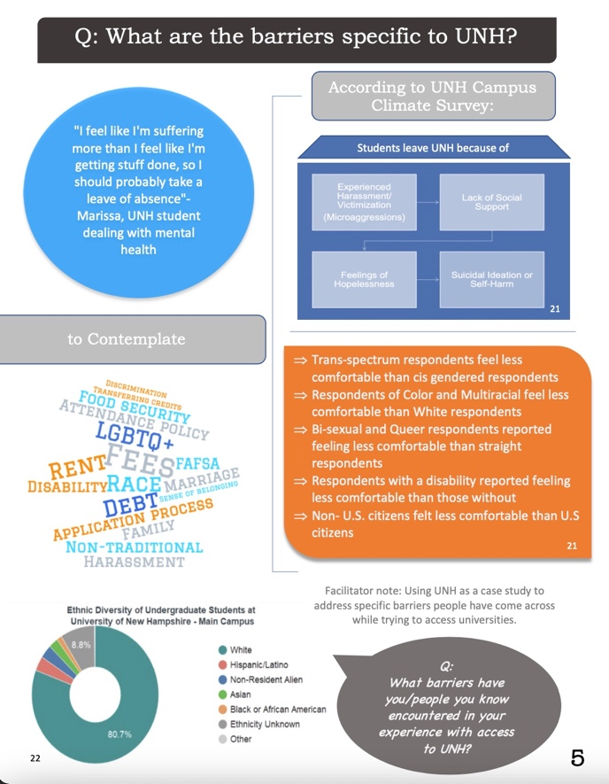
Call to Action:
- Barriers to accessing higher education should be continuously identified and discussed by members of the education community, students, decision-makers, and the general community, to identify the most salient barriers and deepen individual’s perspectives regarding access to higher education
- Members of state college admissions programs should convene to discuss how to lessen the barrier to higher education created by the application process
- High school guidance counselors and teachers should help students throughout the application process to higher education to reduce the impact of this barrier

DELIBERATION OF SOLUTIONS
For the final deliberative stage of the dialogue, participants were asked how they believed the specific barrier that was chosen by the participants should be addressed. For this portion of the dialogue, participants were encouraged to discuss and evaluate different concrete actions that could be taken, at the local, state, or institutional level to address the barrier. Such solutions included expanding or reforming current programs and ideas for policies or programs that have not been enacted but are dreamed for. By asking participants to discuss the merits of specific actions that can be taken on the local level, the CDL hoped to gain an understanding of the opinions of community members on this important topic that could eventually be crystalized and presented to relevant stakeholders. As such, participants were not only encouraged to discuss their dream solutions, but also political and social realities that might impede the implementation or success of the initiatives being discussed. To help engage participants and aid the dialogic process, some of the questions listed below were used at the discretion of the facilitator.
Questions:
- What concrete actions could be taken locally/state-wide?
- What are the consequences of this action?
- What limitations exist? What existing structures would have to bend or change?
- What might be the impacts of this action on others?
- For those who might resist this action, what might be their concerns?
- What would be trade-offs of this action?
- What consequences are we willing to live with?
- Who is responsible for those actions?
- How could we be part of those actions?

During this section of the event, participants shared their personal experiences of working with programs that either helped or hurt their ability to access higher education, how they personally overcome barriers to accessing higher education, what resources would have helped them, and other relevant information. Participants also discussed the merits of various different political policies that have received media attention, such as free four-year or two-year state college tuition, increasing state funding for public institutions of higher learning, and loan forgiveness programs. While each of the dialogues discussed different specific barriers to accessing higher education, some themes that were prevalent through multiple different dialogues can be identified.
These themes included: increasing state funding and support for public institutions of higher learning, creating a connection between businesses and higher education to both help pay for tuition and to increase the marketability of higher education curricula, teaching financial literacy classes in high school, creating a stronger connection between community colleges and four-year public colleges, increasing the availability of scholarships for higher education, and decreasing the stigma against certain types of institutions of higher education, such as trade schools or community colleges. Another common theme that many participants stated was that they believed that barriers to higher education need to be discussed more. Participants believed that more dialogic events, similar to the ones being discussed in this report, should be offered to help increase public knowledge on barriers to higher education and to facilitate the generation of ideas to help decrease the salience of barriers to accessing higher education.
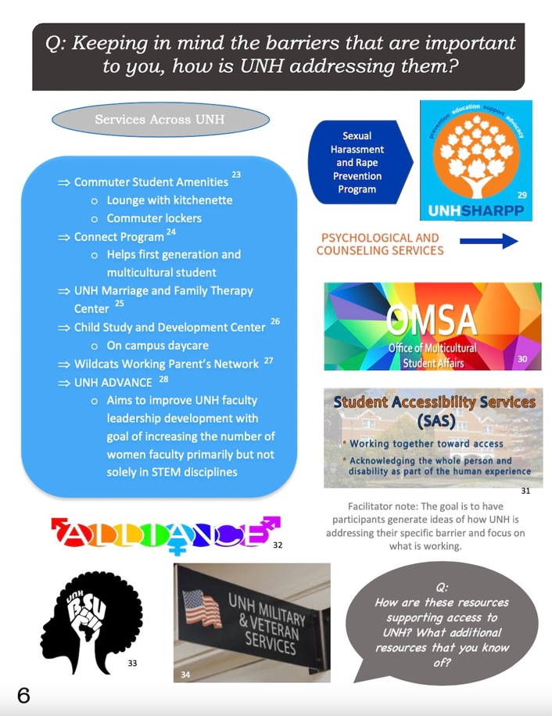
While discussing these solutions, participants engaged in a high-quality evaluation of the policies and ideas presented by wholistically considering the possible implications of the solution in question. This process included participants graciously pushing back on some policies and providing alternative ideas in response. For instance, in one of the dialogues, participants were discussing the merits of including socio-economic background questions on applications for institutions of higher education. Some participants believed that these questions could be used for discriminatory reasons against certain applicants, should not be considered relevant to the merits of the individual applying for an education program, that individuals may feel left out if the ‘box’ that best corresponds to their situation is not included on the form, and that colleges should not feel forced to artificially meet certain diversity quotas. In response to these statements, other participants suggested that socio-economic background questions on applications are also used to hold admissions departments accountable for failing to diversify schools and that without such questions enacting affirmative action policies would be impossible, leading to a decrease in the diversity of student bodies. After participants engaged with each other on this topic and broadened each other’s perspectives on the issue, the group decided that a good compromise would be for admissions departments to continue to ask socio-economic background questions on applications, but that the school should also publish this information and how they used it after each application period closed. This dialogic moment represents the quality of the discussions that occurred throughout these events, the respectfulness of the participants who attended, and the willingness that participants had to change their opinions and broaden their perspectives on access to higher education.
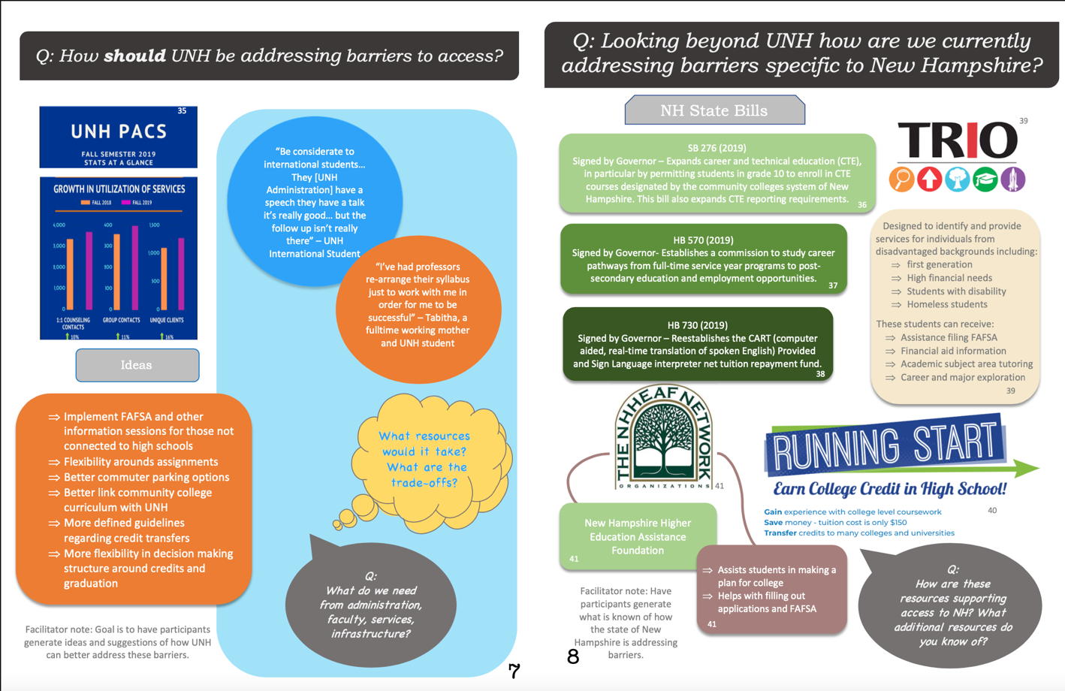
Call to Action:
- High school teachers should teach financial literacy to students before they enter higher education to ensure that students do not make ignorant financial decisions while trying to obtain a higher education
- Decision-makers in the state legislature and representatives from state colleges should convene to discuss increasing funding for state institutions of higher education in an effort to reduce tuition costs
- Businesses should create programs to help employees pay their student loans
- Businesses should explore the possibility of helping decrease the cost of tuition of institutions of higher learning to help facilitate the creation of a well-educated and skilled workforce
- New Hampshire community colleges and UNH should increase their collaborative efforts in an effort to help community college students transition to UNH and to lessen the negative stigma against community colleges
- Efforts by non-profits, businesses, programs, schools, foundations, and the like, to make scholarships available for students seeking higher education should be increased
- The transparency of the use of socio-economic questions on admissions applications to institutions of higher learning should be increased

REFLECTION
In the last stage of the dialogue participants were asked to reflect upon their experience. By engaging in this reflection, the CDL had three main goals. The first goal was that the CDL hoped to learn how to improve the dialogue in the future by learning what participants liked, or did not like, about the event. The second goal was to encourage participants to thoughtfully reflect on their experience as part of the dialogue, the meaning and impact of this experience, and to crystalize their main take-aways from the conversation. The last goal of the reflection was to encourage participants to continue the conversations they had on access to higher education outside of the dialogue and to continue to thoughtfully consider the topic. To help structure the reflection, facilitators used some of the following prompting questions at their discretion.
Questions:
- What is your take-away from our conversation?
- What do we need to, or want to, talk more about?
- Who else needs to be part of the conversation? What perspectives are missing?
- How did this process highlight particular perspectives to access to higher education?
- Did we develop a shared sense of priorities for action? If so, what was it? If not, what was in tension?

When asked what their main take-away from the conversation was, many participants stated that they appreciated hearing and learning from different perspectives, backgrounds, and experiences regarding access to higher education. Despite these differences, participants also stated that these differences did not prevent participants from finding common values and ideas throughout the dialogue. Participants also stated that they learned that “access is so much more than financial burdens” and that this dialogue was part of a learning path to understanding access to higher education that will continue and change.
When responding to the question of how the dialogue could be improved and what perspectives were missing, participants stated that they would have appreciated more perspectives from participants across the country, people of color, and from people who are part of the state legislature, or other relevant organizations, to learn their perspective as to why access to higher education has not been better addressed in New Hampshire. Despite the lack of these voices, participants stated that they enjoyed hearing from the perspectives that were present, especially the multi-generational perspective that was represented in the participants at most of the dialogues.
Participants were pleased with their experience as part of the dialogue and many expressed interest and plans to continue the conversation on access to higher education after the close of the event. One participant stated that “it is refreshing to know others are interesting in this topic. It needs to be talked about more. Access to higher education feels like a bigger problem now that we have spoken about it for an hour and a half,” and expressed that the dialogue inspired him to be more passionate about access to higher education.
RAW DATA
*The following notes are the crystalized notes taking by note-takers during the dialogic events and were used in the creation of this report
When we talk about ‘higher education’, what forms of advanced education are associated?

- Came from very small high school and then was put in private school- cost of private school is similar to college, went to college because it is what parents expected. Knew athletes would normally get a free ride.
- Was in private school and felt expected to go to college- had to wear uniforms daily except for Fridays when seniors would wear sweatshirts of the college they want to attend
- Mother did not finish 6th grade- education stopped at grade 12 from where he is from and felt like there were many opportunities for higher education when he came to the U.S.
- Highschool had a 99% student rate of attending college- heard of student who did not apply, and the high school found out and told him he could not graduate
- Felt like high school did not give her an option to not apply to college- college was the only way
- Goal in high school was for students to go to college- was required to work on college essay in senior year of high school even if there was no thoughts of going to college
- Had CTE in high school that prepares students for college- felt they had no choice other than college
- Dad did not go to school. Mom did. A choice
- Dad did not go to school. He wanted Luca to go to school. Important to educate society to deliberate issues
- Dad drop out. Mom went to school late. Dad believes the most important thing is to be an student because you can gain college on your field. Dad is in military. In general, she thinks it is important because high school and college are very different. Prepare for the workforce
- Dad was a first gen student. Came over from England. Higher education equals opportunity. Opens up the framework to do whatever you want to do
- Both parents graduated. A given that college was supposed to be part of her life. Privilege to be able to go to college. Society expects higher education from people— even when they have economic issues or any other difficulties
- Parents were “small” during the great depression. People believed mom did not have to go to school because she was going to get married. She missed on a lot of opportunities. Dawna’s brothers dropped out and she stayed. Mother was very supportive. Dad died when she was ten. Societal level: high school does not prepare you to the work force. Problem solving skills. Why learning something you will never use? Because of the process
- mother trade school. Marguerite has a degree in culinary school. Came back to school because of the “life style she has seen.” Has seen the difference between those who value blue collar jobs and those who doesn't. Those who are cooking usually have degrees they don't use. They feel like they spent much money. She came back to school because she wants to have better opportunities and higher paid jobs. The fact that someone doesn't go to college does not mean they are not an intellectual
- Father did not go to school, but mother did; higher education was not forced but thought it was a great opportunity, but it is up to the individual
- Father did not go to school, so father felt it was important so pushed it upon him. He thinks it is important to have an educated society to deliberate on issues the society has
- Father dropped out of high school and never went to college, but mother went later on. Parents pushed college upon her because her father thought it would be the best option and one of the only options. Father went into the military and felt stuck so pushed college on her. Thinks it is important for people who want to go to college to be able to.
- Father was a first-generation student; came over from England to go to college, told him that it is very important for him to go to college. Feels as if college students have more opportunities than people who did not attend
- Both parents went to college, so it was already set in her mind. She feels privileged because she knew she was going to go rather than it being a question. Feels as if there is an abundance amount of opportunities with a college degree.
- Important because parents did not go to college; had no help but had the encouragement and support from family to go to college. It is important for society because higher education is different from high school; it gives a lot of critical thinking skills that you would not keep learning. Thinks it is not as much of an expectation to go to college as much as it was a while ago. Access is the most important thing to her; everyone should have the choice and availability.
- Father was in Navy and got degree in service; got a job right out of service but had to go back. Mother went to trade school and became a physical therapist. MK has gone to community college and received two degrees but came back to study engineering. Returned because she did not see opportunities with only an associate’s degree but feels as if a degree does not define someone’s intellectuality.
- In this country we consider education post-high school as higher education; there are a variety of different forms of higher education. Ex. community college. Is a web of different types of forms of education
- Community college, University, trade-school is what first comes to mind.
- Brick and mortar school, online schooling post high school. There are wider ranges of students associated with online learning. Something that expands or helps start your career or whatever it may be
- Was working at UNH and was able to take classes for free. Adult learning is very important because she got her masters at age 52
- Should not matter what age when looking for higher education. Mother and Father took classes around 40 years of age. Feels as if there is a stigma where right out of high school students are pressured to jump into college.
- Think about four-year college, community college, going into an institution after leaving your high school education
- Also, those who need certain qualifications to do a trade school
- Community college, 2, 4 year; trade school; any sort of structured learning beyond high school
- Perspective has shifted since being in higher education; agrees with following statements
- Feelings have shifted since high school; higher education would’ve been four-year university; seemed out of grasp but as he’s grown up learned about all of the different tracks; pursuit of more knowledge

What is the role of higher education in society?

- Higher education is the equalizer. Everyone should have the opportunity to access higher education because within higher education people are able to reach goals that they want to meet post high school. Higher education depending on how it is implemented can keep our class structure in place. It is complicated on what the exact role is.
- There is tension between what society needs and what an individual needs with access to higher ed. We all want to want each other to rise and meet our gifts in the world. Some gifts and gifts in people are valued more than others. There is tension in what has most value and worth in our society
- There are benefits on what higher ed can give to us and our personal growth
- Personal growth is very important. There is a mix in what people value what they are studying. They value it because it is what they want to do but others value it because they are seeking a degree due to how society has formed the value of a degree. There is a gap in between these students.
- Higher ed does not have to be strictly going to college or university there are many other platforms to receive higher education that you are interested in. It depends on the path; there should not be a stigma that people need to go to college. She felt pressured to go to college to make money and get a higher paying job due to the stigma of society that makes people feel like they need to go into college.
- Questions if there is more pressure on females to go to college because men tend to go do higher paying labor jobs more than women.
- Society normalizes men doing labor jobs. She feels like there is mixed genders in college, but more pressure is on females
- Framed for the thing you do in order to secure a stable job
- College degree doesn’t guarantee you financial security after college
- Emphasis the past five years of other option that you can reach financial success; emphasis towards going somewhere that you can afford; not just going somewhere for the name brand
- Feel like they must do this, pinnacle achievement
  - Hierarchy within that; 4-year, community, state school
  - Means different things to different people
  - Proof of being able to get through something tough
  - Escalation in higher education in US
  - Jobs in the US require more qualifications than before
- Things that separate people; separates people by major and hierarchy (HS diploma, associates etc.)
  - People may be roadblocked by lack of degrees
- A foot in the door
- A lot of people go to school to get a better job; works with adults who have experience but are roads blocked by lack of degrees
- Untangling the industry (SAT, ACT) from the academia
  - Good intentions but some people are held back by the industry
  - US college is a watershed moment, big event
  - Don’t spend enough time in HS exploring where they fix; don’t encourage alternate education
- Not everybody is bested by a four-year degree

What is the value of higher education in your own life?

- Feels as if there is value in paths that each individual wants to go- many people do not go to college and it pays off well, people do go to college and it pays off well. Feels like college students look down on people who do not go to college
- Being able to choose where you go after school- Able to dictate own life
- Considered high school as higher education- college gives a lot of experience and broadens horizons to meet new people you would not meet
- Furthers knowledge on what path individuals want to go to
- Higher education can be as high as you can go in your education- important to value what people individually value in their own education, important to make sure the value we hold is broad
- Being able to receive higher education- feels like a lot of people cannot afford higher education so they choose different options other than college
- Not as much of an expectation as it used to be. Wave of anti-elections happening around the country. Everyone should have the choice and ability to access higher education

What barriers to accessing higher education exist (throughout New Hampshire/at UNH?)

- Cost of higher education- everything has a fee to it
- Systemic barrier- acceptance process, financial part
- Home life- Cannot go away to school because needs to take care of family and financially
- Socio economic effect- first generation students are barely able to make it to college then actually having to go to college is hard- costs, new experiences; students cannot adapt
- Costs of resources- notebooks, technology, fridge, food
- Harassment- People should not feel like they cannot be safe
- Disabilities- Schools are ran in a specific way; lectures can be hard for someone with a hearing disability
- Finance
- Great Bay Community College and UNH says you can do 2 years in CC and 2 years at UNH but then UNH makes you repat a year
- People are unsure about what they want to do. Why spend the money. When people are lower income and have to help their family financially
- Price, location (if they can’t get there but also can’t live there), majors that do not interest people, expectation to carry ono a family business
- Family influence. Take on business. Financial. Learning disability
- Income. Financial aid. Scholarships. All top factors
- From a small town in Maine. College was not a big thing for a lot of her friends. A lot of them went to a technical school (automotive, machine repair) Maine is not a good school. Not a good location. People don't have that many options as far as college go. A lot of people go to the military. They thought they were going to get their college paid for but then they get jobs within the military and do not find the need to go to school
- Finances are a barrier to a lot of students, students who are transferring from community college have credits that do not transfer; departments do not think their grades from before are too low to qualify
- Transfer students think they are going to be able to have credits transferred but experience that it is not true and have to end up taking more years
- People are unsure about what they want to do so wonder why they would spend money on college if they don’t know where they are going to be. Family obligations: could be the only source of income for their families so they feel like they can’t go because they need to provide.
- Lack of support; could be from family or community. Lack of opportunity; could not have availability or access based on background and finances
- Price; too expensive. Location; could not get to school. Lack of interest in majors. Expectation to carry on family business; if family own business they are not expected by family to go to college
- Family influence; could want student to carry business on. Finances; debt. Learning disability; not sure how colleges deal with this
- Family influence; could want student to carry business on. Finances; debt. Learning disability; not sure how colleges deal with this
- College was not a huge thing for her friends; most went to technical school as a continuation. Without support, it is hard to feel motivated to go to college. It was not advocated in her high school or by her friends. The military was popular where she was from and got jobs in the military or sent overseas; people think that military will pay for college but then decide not to go because they feel already set up
- Issue of state funding for New Hampshire colleges; least funded in United States
- Funding for K-12 is based on property taxes
- Distance and internet access; north and western parts of state have limited access to connectivity
- Lack of knowledge provided to high school students
- Economic status of an individual
- Lack of Diversity in NH
- State funding
- Physical limitations of college or university; number of students available to have on campus/be supported
- Issues of state funding
- Legislative funding

What barriers have we not shared that you thought about and listed?

- ESL- language barriers for students who do not speak English
- People having kids- Cannot leave them behind
- Encouragement from family and loves ones- It takes work and encouragement for people who did not instantly higher their education after high school

What are some ways these barriers are being addressed in New Hampshire and by UNH?

- Trio- Father is middle school teacher and the school he works at offers programs to get started on college in middle school
- CTE programs- Gets people started; SAS- Helps with disability barrier for students who cannot physically or mentally do what others could do
- PACS- allows students to talk about their adaptation to college
- Program for international students- Big and little brother; allows a companion to be able to talk to while adapting moving from a different country
- Running start program- high schools can provide college credit for taking certain courses; can get a scholarship for this program for people who cannot afford
- Connect program- bring people together to form friend groups coming into UNH
- SHARP- Helps students who experience harassment and advocates for prevention of harassment
- Need to be tech and financial savvy to understand the applying process and what will happen with the loans in 10 years. Feels as if it is a week process just to make sure finances are in order. UNH has been good with communicating with her about the process but community college was not.
- The understanding should be taught in high school; loans, interest rates, signing off on things they do not know. Financial literacy is not talked about enough with families and schools. Programs are important through middle and high school to learn about financial literacy and gain support. Trio scholars’ program has helped students. UNH did a short survey; no matter what their financial income is or families is their main concern is finances.
- Having a finance class implemented in high school would be beneficial. Personal finance was most important class she felt she has taken in college so far. It is crazy to see the money taken out that didn’t have to be.
- Her parents sent three kids to college at the same time but did not receive enough financial aid to cover a lot of the costs. The line between having money but not being rich or in poverty are not talked about, feels as if middle ground is forgotten.
- Financial barrier
  - FAFSA, form help, language barrier
- Work a job and pay for your education; increased cost of education
  - Rely on family, get lucky
- Loan industry (how to do them)
  - Private loans, how to find them
- Lack of Prep in High school
- First time student
  - Lack of awareness about the process
- Credit pull (based off of parents)
  - Need a co-signer
- Familial struggle could prevent you from going to school
- Neuro-diverse barrier???
- Negotiating the application process
  - SAT, ACT, opts out
  - Letter of recommendation
    - May have to ask for it
  - Lots of strings attached to it
  - Switching schools
- Previous academic performances
- Difficulty getting back into the swing of school
  - Anxiety about the process
- Getting and staying in school
  - Maintaining your grades
  - With lower enrollment, schools will lower GPA
- Programs
  - SNHU - SAP appeal
    - If you lose financial aid, you can appeal it; making a contract that you will maintain a 2.0 until your GPA can attain that
    - Have it on a probationary timeline
  - 211 Statewide referral sites
  - Dual enrollment
    - Could be enhanced with the online schooling at the moment
    - Could get an AA
    - Dual Enrollment offers better benefits than AP
  - At CCSNH, we do have a food pantry at some of our sites, things like 'Better Help' counseling service are free for all students. Many of our students are adults who work and attend school.
  - Changing the way you draft a portfolio; how could you change it from how it works now
    - Change the way that students are evaluated
    - “This is the skill I have, here is an example, here is how this school with help benefit me”
      - As opposed to standardized tests
    - I’m ready and I think I will be successful...

How should we address barriers to access to higher education in New Hampshire?

- People should have equal opportunity for paying- college board should give resources to scholarships, way to pay, opportunities
- Work Study- allows you to work and receive financial aid
- Scholarships- Should make scholarships not through a university be more public and known by students
- Application fees- Free application fees; knows students who have not applied to school because application fee is too high
- Scholarships- Private scholarships should give less money but to more people rather than having one large scholarship to one person
- Scholarships- Make scholarships more public to students; got scholarship but would have never known if someone did not tell her about it
- Admissions- Should be held accountable for diversifying schools. There should not be discrimination in the decision process.
- There needs to be transparency- people do not apply to scholarships because they feel as if they will not get it; they should be clearer on what target group they are looking for.
- Admissions- There should not be discrimination in the admission process.
- Return of investment- Universities tend to look at students if they are “worth it”; if they have money and will donate after attending
- Application process: take out the questions about background so there is no chance of discrimination; schools are not clear on what they are using the information for
- High schools having a scholarship night- Encourages students to apply to many scholarships
- Pros/Cons of taking away Background Questions on applications
  - Universities- Colleges can do what they want with their information. Q; How do we hold universities accountable for statistics if we take away background questions?
  - Colleges use background questions to discriminate- UNH does not use statistics from questions in a helpful way
  - Colleges use background questions to discriminate- They try to seek out the best from the results of background questions; students should be integrated.
  - University uses background questions to meet quota for diversity of students bases off of race, sex, test scores
  - Background questions did not provide enough boxes on college applications
  - Reasoning of questions are because of socio economic issues- if there were no questions then colleges could be accused of discrimination if they do not provide statistics
  - Different schools have different funding- High schools coming from a low-income area do not provide resources to higher education; there should be non-profits that
- Need to be savvy with technology and finance to understand the ways the loan work. How much time they have to pay….. A weeklong process to apply to make sure they are covering all the scholarships we can get…. She has to be on top of whether it is accepted. UNH has a good amount of reviewing the process which makes it a bit faster
- Financial literacy should be though in high school. Family don’t often talk about that. Pages 6-8 talks about trio. Someone students get a bit more support through the trio scholar program. Last fall they did a survey with first year student. Finance still a big concern for them. NH very expensive and gets little support from the state. Look for more donors for extra financial aid. Some scholarships are only applicable for one year. Sometimes you apply to 50 scholarships and get one
- Finance class would help a lot of people. She had advisory that helped her choose a personal finance class. She did not like math and that was an “Easy” class, but she thinks it is one of the most important class she has ever taken in college. Credit cards. Budget. Putting down what she was spending.
- She does not fall in a huge financial aid group. At a point they were sending 3 kids to college and they were still not getting that much help. Thankfully they could help but she knows they were still under a lot of pressure. The people who are not in the poverty line but also are not wealthy. The middle class is kind of forgotten sometimes. The middle ground is almost “Forgotten” is a weird privilege.
- Comes from a family that does not talk much about finance, but she assumes things are fine. It was not until later that she found out her stepmom was 100 thousand dollars on loan. It was terrifying. Her stepmom did not want to scar her. But she thinks it is important to have that reality check
- A lot adults still don’t understand their loans. Didn’t get her PHD until she was 40. Working in non-profits did not realize she was working in higher ed. She did not realize she could have her job pay for her PHD. 100 thousand dollars in debt. She is going to be in debt until she is 70.
- I would prefer to go to a school with a bunch of luxuries (football stadium) if that meant i could pay less. Not a lot of scholarships to pay already existing debt
- Taking ap classes. Working 25 hours. Did not have time/motivation to apply for scholarships. Now she wishes she would have
She was a d1 student in mass. Although general students do not benefit from stadium and athletes. People who are recruited do. Some students need that money to have access to higher ed
- In NH you have to go to a pricy school to get a bachelor's degree
- Agree with all. Finances can shift your decision in terms of what school you choose to go to. We are talking about who expensive UNH but if you are in state is pretty cheap. He had the opportunity to go to other schools in Boston that were better, but he could not afford
- Would increasing funding for Community Colleges help?
  - Offering a bachelor’s degree in community college would be good because it is just… right now
  - There is a big stigma around community college
  - Yes. I have been to a really good college and really bad good college. There should be a better notion of what is best or worse
  - There’s a really good community college in Maine. People would make fun of people who would post letter of acceptance for that college. If we can’t end the stigma around, I don’t know what we would do it… but do work in the community colleges to make all of them good…. Employers will look at give the same value as they give UNH
  - Do no community colleges offer bachelors?
  - Some do, but they have to go through an additional process
  - State college could be working more closely with state schools
  - Community college is the reason why I have been able to go to UNH. Scholarships. More access to financial help because of community college
  - A lot of students do not want to go to community college because they want the experience
  - Adding on to the stereo type…. Same go to trade school. A lot of friends are in trade schools they already have their degree and have no doubt. Who is really getting ahead? The stigma has to end and we need more “trades”
  - Agree, Honestly…. Thought I was going to do physical therapy and now I am in communication. There’s no coalition. I would had been better off if i had gone to community college first, At the moment his friends in trade school have more money than him. You can get a lot of trade school. Is important to know that trades are still very useful and important
- What are actions that we can take for people in high school, how their families understand their education and the meaning of education? How to prepare students to think higher education is the option for them and how they make it affordable going into it?
  - High schools should educate students more about loans and debt and ways to. Stepmother is 100 thousand dollars in debt because of school loans but it was never talked about in family discussions. She feels like people should know that they are signing up for a lifetime of financial burden
  - Did not get higher degree until 40 but did not know of other options. Did not know if she worked at a state school she could get a lot potentially for free. Feels like people need to be more educated about other options
  - If more people started attending trade schools prices would go down. Feels as if they don’t need all of the amenities college gives. There are options to apply for scholarships before accumulating debt but no options for scholarships after debt is already made.
  - Never applied to scholarships but wish she did and wants everyone to. People are lazy about scholarships because they do not want to do the process it takes to get one.
  - Recruited for field hockey but got a scholarship for in-state school so chose to go there. Made the wrong choice because she was only thinking about how it was less money. Never applied to scholarships outside of sports. Chose to come to UNH and not play the sport
  - You need to get a bachelor's degree from a college that has a high tuition rate; thinks there should be other choices to receive a bachelor's degree other than attending a state college or university
  - Felt there could have been better experiences elsewhere but was not close to affording it
- Offering bachelor's degrees through community college
- Erasing bad stigma around community college
- Work on making community colleges better and also erasing the stigma around community college; the stigma is that it is just another high school, and everyone is accepted. Offer 4-year programs in community college.
- Community colleges have to go through a process in order to give out a bachelor's degree. Community college has to work with students on so many different levels because it accepts everyone that has a GED or high school diploma. State schools should be working more in depth with community colleges so students can transfer
- There is an opportunity to get scholarships to 4-year colleges from community college
- People do not choose community college because they want the experience of living on campus, but some people only have the option for community college
- A lot of friends who are in trade school have already gotten out of school and have a job. The stigma around trade school and community college needs to be changed.
- Wishes he went to community college because he feels as if it would be cheaper and sees his friends succeed in that path.
- Pathways program has been going on for 3 years
- The pathways program has been going on in pieces for the past decade. It has grown throughout her time working at the community college. The program was not organized at first and left students wondering if they were going on the right path. It has been organized since and community colleges now have access to high quality advising and courses that are equivalent to 4-year colleges.
- The institution provides scholarships and works to help support the students. Waiving of application fees.
- Running start program; earning college credits in high school which helps save money and allows credits to transfer. In high school, was able to gain college credits but they didn’t end up transferring over. Knows student from Maine who was able to receive a large amount of college credits as an incoming freshman she was considered a junior. O felt as if she was not informed more on classes that were equivalent to college credits in high school.
- The legislature in this state will never change or it is really hard to imagine. It would be a massive cultural change for this state. There is talk about attracting business to our state; businesses look at the funding for k-12 students and college students and make the decision to start a business based on that information
- Having students run labs. Having an incentive would be helpful for growth. Making money back for every dollar one spends; introduce to legislative offices.
- State related funding is the biggest issue; with freedom we should be able to do more things but we have become reliant on state funding. Getting money from alumni should be pushed for. Individuals with money to give should be giving back.
- One complexity of m’s model is that higher education is expensive because higher education is made to be offered to a broad range of people. Harvard is more likely to get money from alumni because the 1 % gives to the 1%
- Corporate tax cuts are very significant. Offices would benefit from highly educated people. There should be a deal where corporates give back to receiving highly educated people
- Do we know why New Hampshire has least funding?
- Live free or die. People have individualized notions. If you want it then you pay for it.
- What is the most funded state? California?
- New York, perhaps. New York invests in students which is different from New Hampshire. New York invests in students so that they can work in the city of New York.
- Higher education gives personal growth and it benefits society. People who do not work in education need to be informed more on the whole aspect of access to higher education.
- There is a lack of education regarding politics. Arguments are read one way by one group and another way by the other. Our education models are limited and we need to make it available to more people.
- Figure out the needs of companies and students to send them into higher education. We will see a growth in the way corporations will support students and sending their employees to school to gain a higher education.
- We need to figure out how to change the system. It is hard because the system has been growing for decades and decades.
- The student debt crisis is something that we cannot continue to have generations begin their life after school carrying debt for the rest of their life.
- Hopefully student loan forgiveness is something that will form in the future.
- Corporations should be involved with educating students. They should help pay off the debt of their employees that went to school and pay to continue their education.
- Needs grad school but does not want to be buried in debt. Hope is that when she graduates she can find a job that is willing to send her back to school and pay for it.
- New Hampshire charitable foundations helps give money to students who come from small families. If you have a lot of debt it decreases the likelihood that they will want to go back to school for masters. We need a debate around funding for higher education.
- Higher education is not talked about enough.
- Offering scholarships
- In relation to veterans
  - Entitled to GI Bill
  - Must maintain a certain amount of credits
  - Have to pay it back
- At state level
  - NH and Vermont lowest funding, highest tuition
  - Not as much revenue due to no taxes
  - Dartmouth - free tuition for families who make less than 100000
    - If there would be a similar thing for the community college
    - Train a lot of nurses
- Revamp the funding at the federal system
  - For students whose parents don't have a lot of credit
- Pathway students
  - How some classes don’t transfer
  - Minimize the need to repeat approaches
  - More streamlined approach
- College for America SNHU
  - Stackability; opt out and walk away with associates
    - Or you could continue
- More professional associates degree programs
- Very expensive for in-state but when you look elsewhere it's still the cheapest option
- Pros and Cons of lower public university and community college price
  - Restructuring system; is you are a dependent that doesn’t mean your parents are helping you
  - So focused on trying to get everything done, we aren’t enraged by certain systems
    - We need to be upset about it; spend a lot of money on military, why are we not spending money on our young people and their education
  - More investment in the youth; “everything comes from the roots” Some kids just need a shot
  - Get rid of the stigma around trade school, community college, lower-level degrees
  - Give more funding to places where kids don’t get it; i.e. inner city
  - Different avenues for success
  - Looking at the way we structure our loan system; what are these loans
  - Governments re-appropriating funds; get businesses on board
  - Have businesses go to high schools to help train individuals to enter their specific field
  - Teachers shouldn’t have to incur a huge amount of debt (sustain huge amount of debt and then enter the field where they don’t make a lot of money)
  - Public Service Loan Forgiveness Scandal
    - Minimum loan payment for 10 years; do your public service for 10 years
    - Your loans would be forgiven; not a lot of people where accepted
  - We need a Public Education Representative (head) who knows about education
  - Lot of master programs require a year of unpaid full time service; not feasible
  - Pros
    - People could afford it
    - Much more accessible
  - Cons
    - Tuition money is how they fund the jobs
      - Covid has brought a lot of insecurity about that
    - How would they fund these specific community services
      - State funding would be the answer
      - Public institution attracts for everybody but also attracts certain people to raise their ranking (con seem by university)

What is your main take-away?

- A lot of experience and issues. If we work together we can diminish some of the burdens
- So many different barriers. Finance is a part of it. Finances is the widely known
- Everyone experiences and know about it. But nothing has been done. It is important to end the stigma. There should be some actions. Those who are aware of the issue do something about it
- Excited to hear some many people are first gen. Good that people are breaking those barriers
- This weekend we did a first gen celebration….. A lack of political will to diverse higher education. There’s plenty of many than can be put into education. Happy to see Joe Biden is a community college professor .. everyone’s experiences are important
- A lot of more share communalities among students. Good to get different viewpoints
- A lot of different perspective. Interesting that community college…. Did not have that much knowledge about it
- Very clear that we all saw value in higher education. Important to continue having these conversations
- Wish had taken personal finance class. Save people before they do anything that will put them at bad position
- Access to higher education is so much more than financial burdens but it is good to dig deep on one issue. People need to work together to diminish the tensions
- So many different barriers to accessing higher education but thinks finance was very important to talk about; it is a widely known barrier. There is something to be said about that we all know about this burden, but minimal things are happening about it. It is important to eliminate stigmas around community college and trade school; wants to see action.
- Was excited to see how many are first generations; it’s important to break those barriers when you have the option too.
- There are a lot of first-gen students in UNH; solid 1 and 4 are in the situation. There is a lack of political will to invest in and diversify avenues of finances for college, trade school, and community college. Enjoyed seeing people are participating in a conversation like this
- There are a lot more shared commonalities that students at UNH share and it was nice to see different types of people sharing these commonalities
- We all have different perspectives and experiences, but people have shared views on important subjects; feels as if he did not have as much knowledge of this issue before the conversation
- It is important that we all got to see the value of higher education
- Enjoyed talking about the importance of personal finance and wishes she had taken the course in high school to learn more before college.
- We need to talk about access to higher education more; we do not talk about it enough.
- It is refreshing to know others are interested in this topic; It needs to be talked about more. This feels like a bigger problem now that we have spoken about it for an hour and a half. This discussion has sparked him to be more passionate about this subject.
- Funding and not having access is. It is good that people are talking about this because not enough people are. This conversation will lead her to talk about it more with others.
- Feels not alone in concerns around this subject. We need to have conversations with people who do not typically start in the same place. She will seek out people to talk to about this issue.
- Glad she found the civil discourse lab and that there are other people who are interested in this topic and want to make a difference. Enjoys the deliberation that came from this talk; is glad she is able to talk to someone about this issue with people different than friends and family.
- Different perspectives
  - Different level of education and how they were thought about on different levels
- Strong level of cohesion
- Different backgrounds and experiences
- Get POC and different parts of the country involved
- Student vs those who work in higher ed perspectives
  - Backgrounds and roles are different but we all see similar themes
  - What shifts need to be made
- Other perspectives on why we are still here; having the other side advocate
  - Here from those in power
- Interesting to hear the different levels and how changes can be made
  - Change can come from high schools, politicians etc.
- We are stuck in a cycle; stuck in the barriers of higher education;
- Need to figure out how to change it...how to break out

What did we learn?

- Learned about broad range of barriers that students come across while trying to receive access to higher education
- Learned how others have grown up knowing about higher education and participants learned about him.
- Learned about different perspectives that has not know- learned how important it is to know these perspectives
- Did not know about NH bills that have been passed
- People have different perspectives on what higher education is and how it is valued
- There are a lot more issues than one would think, and a lot needs to be fixed

What do we need to/want to talk about more?

- Solutions to shorten barriers
- What other people understand to be true about higher education-we need more dialogue
- Bring bigger organizations into conversations to see their stances on these issues and if they are genuine and have the public good in mind
- The debt and student loans associated with higher education
- Work study programs and how there are easier ways for students to pay their ways through college.

How do people feel about this structure of deliberation, if it were to be held on larger scales?
- As long as someone is facilitating and note-taking it feels as if it is making a difference within the flow of a normal conversation.
- Enjoys the multi-generational aspect of the dialogue around this deliberation.
- Feels invested in the younger participants and acknowledges that this is important to hear other stories. Is important on how quickly feelings can form from conversation.
- A large forum with a multi-generational mix will be very effective

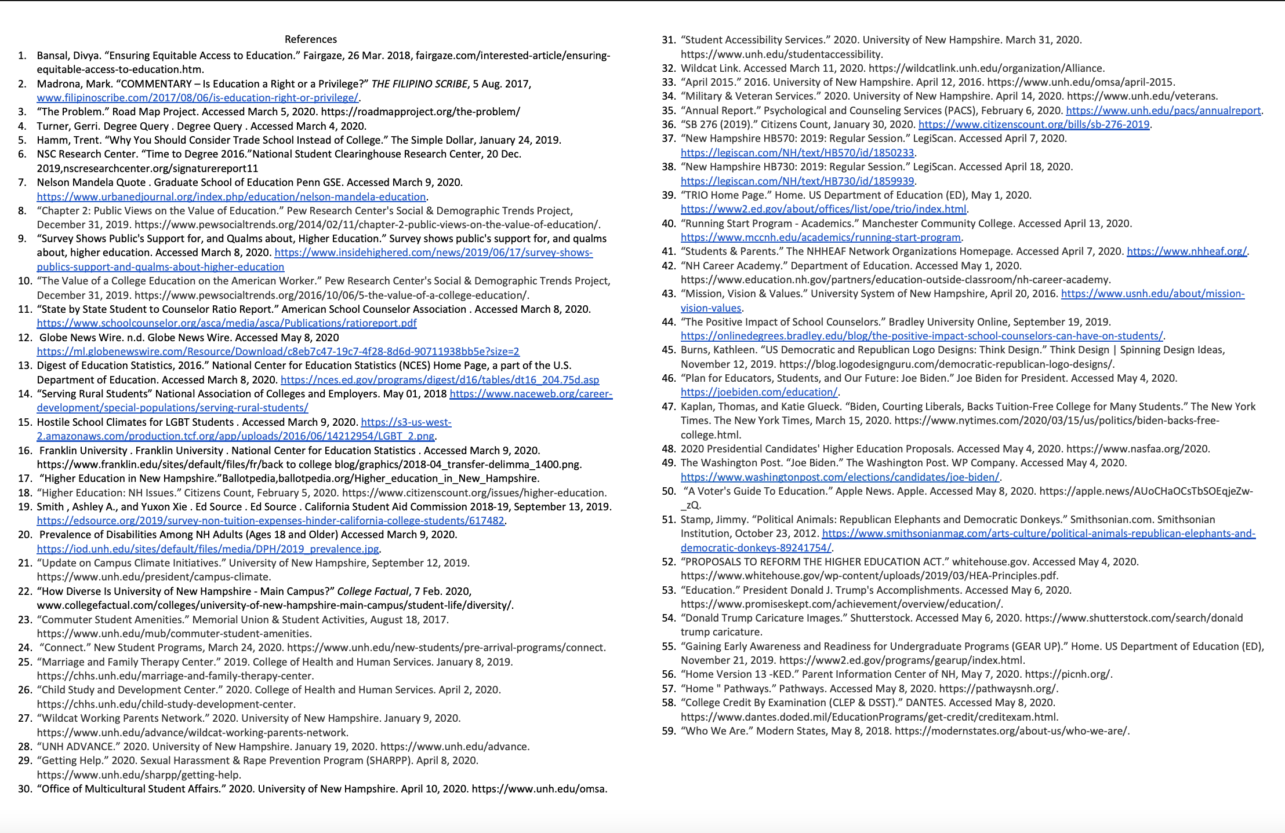
PROGRAM GUIDE SOURCES

